Index of Facebook Recipe Collection # 3 by Page Number

- Comfort Breakfast Bake
- Oven Baked Fajita
- Chocolate Chip Ooey Gooey Butter Cake
- Old Fashion Chocolate Pie
- Loaded Chicken & Potatoes
- Cookies And Cream
- Canada's Best Carrot Cake With Cream Cheese Icing
- Cheesy Ham Biscuit Pull Aparts
- Tortilla Chicken Casserole
- El Torito's Tortilla Soup
- Caramel Apple Bites
- Texas-Style Lasagna Recipe
- Buffalo Chicken Garbage Bread
- Amazing Caramel Sauce
- Fried Cabbage With Sausage
- Bacon Wrapped Stuffed Mushrooms
- Copycat Chick-Fil-A Nuggets & Honey Mustard Dipping Sauce
- Cracker Barrel Hashbrown Casserole
- Raw Chocolate Walnut Ice Cream
- Best Steak Marinade In Existence
- Miss Mary Bobo's Meatloaf
- Better Than Fries - Whole Potato Slices
- No Bake Energy Bites
- Adorable Dr Seuss Cookies
- Pepperoni And Mozzarella Pull Apart Bread
- Oreo Turkeys
- Avocado Chicken Enchiladas
- Make Meatloaf In A Muffin Pan
- Unstuffed Cabbage Rolls
- No-Bake Chewy Granola Bars
- Healthy Sweet Tooth Treats
- Really Good Salsa
- Better-Than-Takeout-Fried-Rice
- Blueberry Lime Cream Cheese Pound Cake
- Chicken & Spinach Pasta Bake
- Candy Sleighs
- Garlic & Lemon Chicken
- 3 Ingredient Chicken
- Ice Cream Sandwich Cake
- Caramel Cake
- Peach Cobbler
- Homemade Apple Fritters
- Brown Sugar Carmel Pound Cake
- Corn Casserole
- Home Made Sauerkraut
- Ihop Cheesecake Pancakes
- Pumpkin Cake With Apple Cider Glaze
- Iced Pecans
- Baked Cheese Balls
- Crock Pot Lasagna
- Pumpkin Whoopie Pies
- Pistachio Pudding Dessert
- Oven Baked Cabbage Rolls
- No-Bake Peanut Butter Bars
- Crescent Pecan Pie Squares
- Spring Cleanse ~ Your Body
- Cream Cheese Pound Cake
- Pumpkin Snickerdoodles
- Smartie Cookies
- Carrot And Zucchini Bars
- Broccoli Cheese Soup For The Crock Pot
- Chocolate Kiss Cherry Cookies
- Zucchini Brownies
- 2 Ingredient Magic Cake
- Fresh Apple Cake
- Orange Zucchini Bread
- Italian Style Goulash Recipe
- Cream Cheese Candies-No Bake
- Crock Pot Sweet Garlic Chicken
- State Fair Funnel Cakes
- Bacon Bombs
- Connie's Danish Heirloom Layer Cake
- Frozen Peanut Butter Cheesecake
- Red Velvet Cheesecake
- Starbucks Lemon Loaf
- Homemade Ketchup
- Nutella Brownie
- Apple Cinnamon Loaf
- Honey Garlic Pork Chops
- Chicken Pot Pie
- Breakfast Casserole In The Crock Pot
- Pizza Balls
- Quick Cinnamon Rolls - No Yeast
- Ranch Crock Pot Pork Chops
- Roasted Ranch Potatoes
- Snickerdoodle Bread
- Raspberry Zinger Poke Cake
- Secretly Healthy Spinach Dip
- Chicken Fried Steak
- Roasted Garlic Mushrooms
- Taco Casserole – Salad – Or Dip
- Ranch Dressing – Low Fat
- Fresh Zucchini Cookies
- Meatball Sandwich Casserole
- Sweet Grape Salad
- Easiest Fudge Ever
- Outback Steakhouse Alice Springs Chicken
- Pear Zucchini Bread
- Party Style Smokies
- Franks And Corn Bread

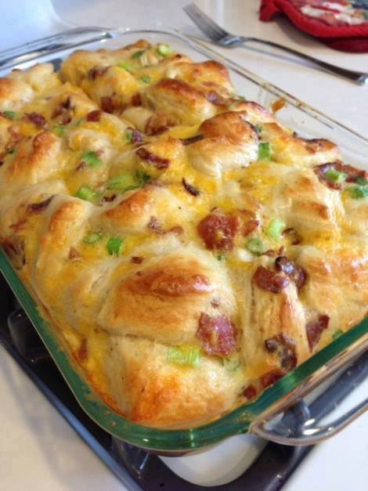
Comfort Breakfast Bake
5 eggs
1/4 cup milk
16 oz refrigerated breakfast biscuits (I used the Pillsbury flakey kind)
4 scallions (green onions, spring onions, whatever you prefer to call them)
1 cup shredded extra sharp cheddar cheese
If you’re into the meats – cooked center cut bacon or cooked sausage
11×17 pan, sprayed with cooking spray (Note: I think a 9×13 works better, but it might need to bake a little longer)
1. Mix your eggs and milk in a large bowl. Cut each biscuit (I’m all about scissors in the kitchen) into fours and add it to the bowl. I like to do this before I cook the bacon or cut up the scallions – give the biscuits some time to really soak in the eggs.
2. Cut up your scallions, shred your cheese, cook and break up your bacon (or sausage). Add everything to the bowl.
3. Mix it all up and pour into your pan. Bake at 350 for 25 minutes (make sure it isn't runny – mine this morning took 28 mins).

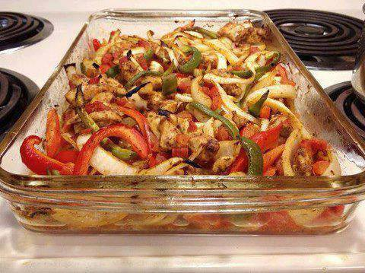
Oven Baked Fajita
Ingredients:
1 pound boneless, skinless chicken breasts, cut into strips
2 Tbsp vegetable oil
2 tsp chili powder
1 1/2 tsp cumin
1/2 tsp garlic powder
1/2 tsp dried oregano
1/4 tsp seasoned salt
1 (15 oz) can diced tomatoes with green chilies (Rotel)
1 medium onion, sliced
1/2 red bell pepper, cut into strips
1/2 green bell pepper, cut into strips
Directions:
Preheat the oven to 400 degrees. Place chicken strips in a greased 13×9 baking dish.
In a small bowl combine the oil, chili powder, cumin, garlic powder, dried oregano, and salt.
Drizzle the spice mixture over the chicken and stir to coat.
Next add the tomatoes, peppers, and onions to the dish and stir to combine.
Bake uncovered for 20-25 minutes or until chicken is cooked through and the vegetables are tender.

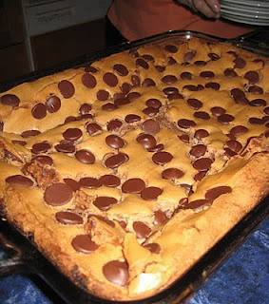
~ Chocolate Chip Ooey Gooey Butter Cake ~
Cake Base Layer
1 (18.25-ounce) box yellow cake mix
1 egg
1/2 cup (1 stick) butter, melted
Filling Layer
1 (8-ounce) package cream cheese, softened
2 eggs
1 teaspoon pure vanilla extract
1 (16-ounce) box confectioners' sugar
1/2 cup (1 stick) butter, melted
Topping
1 cup chocolate chips
1 cup chopped nuts (optional)
Directions
Preheat oven to 350 degrees. Lightly grease a 13 x 9 x 2-inch baking pan. In the bowl of an electric mixer, combine cake mix, egg, and butter and mix well. Pat into the bottom of prepared pan and set aside. Still using an electric mixer, beat cream cheese until smooth; add eggs and vanilla. Dump in confectioners' sugar and beat well. Reduce speed of mixer and slowly pour in butter. Mix well.
Pour filling onto cake mixture and spread evenly. Sprinkle 1 cup chocolate chips and 1 cup chopped nuts on top of filling. Bake for 40 to 50 minutes. Don't be afraid to make a judgment call on the cooking time, because oven temperatures can vary. You want the center to be a little gooey. *** Feel free to add me as a friend or follow me. I am always sharing awesome stuff!!!

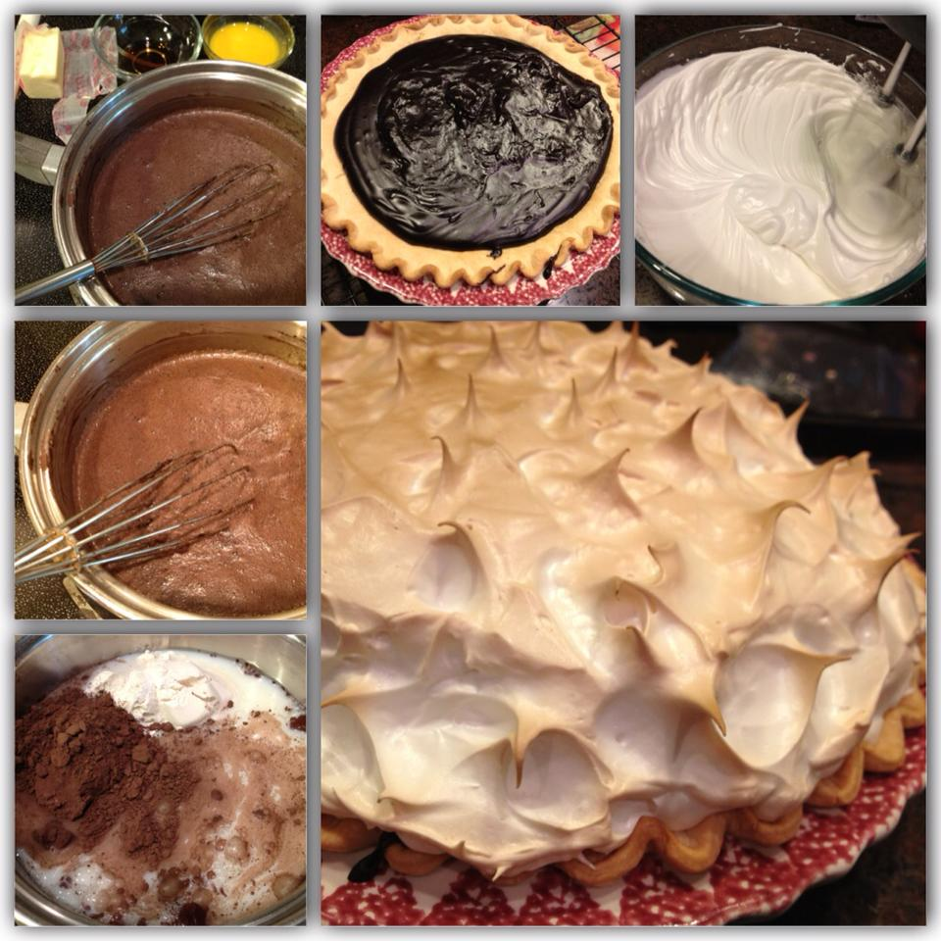
Old Fashion Chocolate Pie
1c sugar
4tbsp cocoa (I use special dark)
2c milk
2 egg yolks
5tbsp flour
1/2 stick salted butter
1tsp vanilla
1 baked 9in pie crust
Mix the sugar, cocoa, and flour well in a thick pot. Add milk. Cook on medium until it begins to thicken. Stir like crazy for at least 5min to keep it from sticking and burning. Add beaten *egg yolk and butter; cook for 1min more. Add vanilla then pour into your cooked pie crust and cool before you add meringue.
*note: add a little of the chocolate mixture to the egg yolk that it won't cook the eggs immediately when you add it to the pot.
Meringue
3 egg whites
1/4tsp cream of tartar
1/2tsp vanilla
6tbsp sugar
Beat the egg whites, cream of tartar, and vanilla until soft peaks form. Slowly add 1tbsp of sugar at a time. Beat until hard peaks form and sugar is dissolved. Spread on top of your pie all the way to the edge of your crust to keep the meringue from shrinking. Bake 350 degrees for 10-12min or until desired browning had occurred.
Cool before you refrigerate or your meringue will weep and shrink.

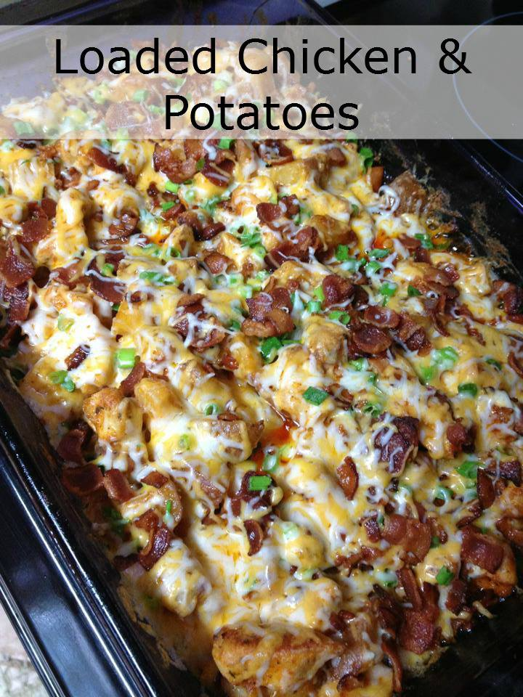
Loaded Chicken & Potatoes
Ingredients:
1 lb boneless chicken breasts, cubed (1″)
6-8 medium skin on red potatoes, cut in 1/2″ cubes
1/3 c olive oil
1 1/2 tsp salt
1 tsp black pepper
1 Tbsp paprika
2 Tbsp garlic powder
2 Tbsp hot sauce (more if you like it HOT)
Topping:
2 c fiesta blend cheese
1 c crumbled bacon
1 c diced green onion
How to Make:
1. Preheat oven to 400 degrees. Spray a 9X13″ baking dish with cooking spray.
2. In a large bowl, mix together the olive oil, salt, pepper, paprika, garlic powder, and hot sauce. Add the cubed potatoes and chicken and stir to coat. Carefully scoop the potatoes and chicken into the prepared baking dish..
3. Bake the potatoes and chicken for 55-60 minutes, stirring every 20 minutes, until cooked through, crispy, and browned on the outside. While the potatoes are cooking, fry your bacon (about half a pound).
4. Once the potatoes and chicken are fully cooked, remove from the oven. Top the cooked potatoes with the the cheese, bacon, and green onion. Return the casserole to the oven and bake for 5 minutes or until cheese is melted.
Serve With: extra hot sauce and/or ranch dressing or sour cream!
I'm not to fond of hot sauce, so I substituted sweet baby rays honey BBQ sauce. Came out amazing!
Another Person Substituted the potatoes for califlower, regular cheese for half non fat half low fat and the bacon for turkey sausage and substituted the oil for nonfat and low sodium cream soup. Used nonfat cooking spray and foil on my baking dish. Much much healthier and still super tsdty.
Another Person Said It's good with packet of ranch mix instead of hot sauce

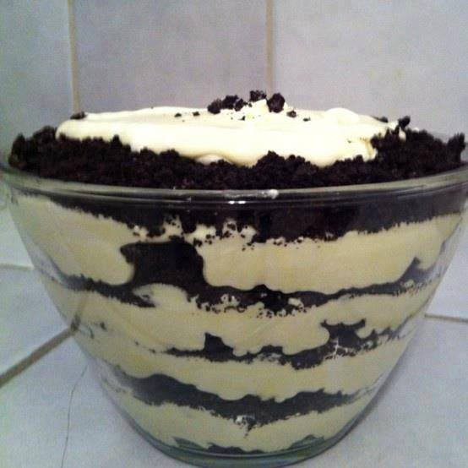
COOKIES AND CREAM~
EVERY TIME I SERVE THIS AT A COOKOUT IT IS DEVOURED AND THEN EVERYONE WANTS THE RECIPE~SO SO GOOOOD~~~Oreo goodness:
1 bag Oreos, crushed
8oz cream cheese, softened
1/4 cup butter
1 cup powdered sugar
3 cups milk
2 sm boxes instant vanilla pudding
1/2 tsp vanilla
12 oz Cool Whip, thawed
Cream together cream cheese, butter & powered sugar & vanilla. In separate bowl mix milk & pudding chill until set. Fold in cool whip after pudding has set. Add cream cheese mixture, layer with Oreos... Chill until ready to serve!

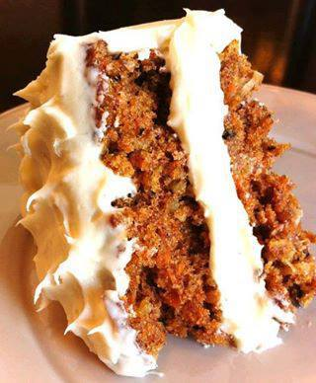
Canada's Best Carrot Cake with Cream Cheese Icing
Ingredients
2 cups (500 mL) all-purpose flour
2 tsp (10 mL) baking powder
2 tsp (10 mL) cinnamon
1 tsp (5 mL) baking soda
3/4 tsp (4 mL) salt
1/2 tsp (2 mL) nutmeg
3/4 cup (175 mL) granulated sugar
3/4 cup (175 mL) packed brown sugar
3 eggs
3/4 cup (175 mL) vegetable oil
1 tsp (5 mL) vanilla
2 cups (500 mL) grated carrots
1 cup (250 mL) drained crushed canned pineapple
1/2 cup (125 mL) chopped pecans
Icing:
1 8 oz (250g) package cream cheese, softened
1/4 cup (60 mL) butter, softened
1/2 tsp (2 mL) vanilla
1 cup (250 mL) icing sugar (aka confectioners sugar and powdered sugar)
Preparation
Grease and flour 13- x 9-inch (3.5 L) metal cake pan; (or 2 round pans) set aside.
In large bowl, whisk together flour, baking powder, cinnamon, baking soda, salt and nutmeg. In separate bowl, beat together granulated and brown sugars, eggs, oil and vanilla until smooth; pour over flour mixture and stir just until moistened. Stir in carrots, pineapple and pecans. Spread in prepared pan.
Bake in centre of 350°F (180°C) oven for 40 minutes or until cake tester inserted in centre comes out clean. Let cool in pan on rack. (Make-ahead: Cover with plastic wrap and store at room temperature for up to 2 days. Or ovenwrap with heavy duty foil and freeze for up to 2 weeks; let thaw before continuing.)
Icing: In bowl, beat cream cheese with butter until smooth. Beat in vanilla. Beat in icing sugar, one-third at a time, until smooth. Spread over top of cake. (Make-ahead: Cover loosely and refrigerate for up to I day.)
Source: Canadian Living magazine
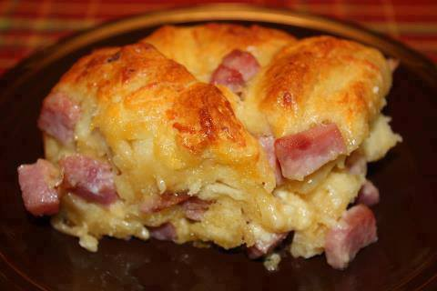
Cheesy Ham Biscuit Pull Aparts
1 (16.3 oz) Pillsbury Grands Flaky Layers Biscuits (I used the buttery flavor).
1 egg
2 tablespoons milk
3/4 cup diced ham
1/4 cup thinly sliced green onion
1/2 cup shredded cheddar
1/2 cup Monterey Jack cheese
1/2 teaspoon granulated garlic
Heat oven to 350 degrees. Spray a 11 x 7 or 12 x 8 glass baking dish with cooking spray. In a large bowl, beat egg and milk with a wire whisk until smooth.
Separate dough into individual biscuits and cut each biscuit into quarters. Gently stir biscuit pieces into egg mixture to coat evenly. Fold in ham, cheese, onions and granulated garlic. Spoon mixture into prepared dish, arrange biscuit pieces in a single layer.
Baked at 350 for 23 - 25 minutes or until golden brown. You can either cut into squares or just pull apart and serve.

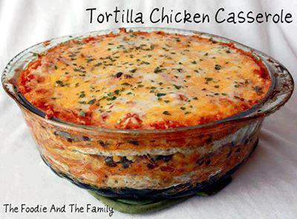
Tortilla Chicken Casserole
Makes 12 servings
Ingredients:
8 multigrain flour tortillas
3 cups chopped chicken
1 tablespoon olive oil
1 cup chopped onion
1 cup chopped red pepper
19oz black beans
14oz canned corn
1 tsp chili powder
3 cups salsa
1 1/2 cups sour cream
1 1/2 cup jalapeno monterey jack cheese, shredded
1 1/2 cup cheddar cheese, shredded
1 tablespoons finely chopped cilantro
Directions:
Preheat oven to 350. Spray a casserole dish large enough to fit tortillas. Heat olive oil in sautéing pan; sauté onion and red pepper for 5 minutes, until softened. Mix in chili powder, remove from heat, stir in black beans and corn.
In a medium bowl, mix salsa and sour cream. Layer tortilla, salsa mixture, chicken, tortilla, vegetables, cheeses. Repeat 4 times, or until you reach the top of the casserole. *NOTE: Stop layering once you reach the top of your casserole dish and top with cheese* Cover and bake for 25 minutes. Uncover and bake 10-15 minutes longer or until cheese is bubbly and browning. Let stand for 10 minutes before serving. Sprinkle with chopped cilantro and cut into 12 pie shaped wedges...
SOURCE: thefoodieandthefamily.com

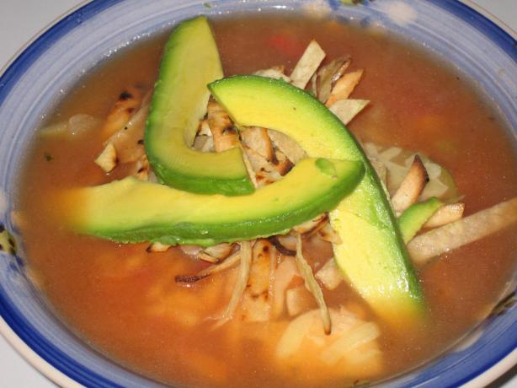
El Torito's Tortilla Soup
Ingredients:

2 chicken breasts; boneless, skinless
3 quart chicken broth
1 red onion, diced
2 carrots, diced
1 boiling potato, diced
1/4 cup tomato paste
1 bay leaf
2 cloves garlic, chopped
1/2 teaspoon chipotle chile en adobo, pureed
1 teaspoon pickled jalapeno chile seeded, chopped
1 teaspoon dried Mexican oregano
1/8 teaspoon cumin
salt, to taste
white pepper, to taste
1 zucchini, diced
1 yellow squash, diced
1/2 red bell pepper, diced
juice from 1 lime
2 tablespoon sweet Sherry (preferably Harvey's Bristol Cream)
1 tablespoon cilantro, chopped
1 tablespoon fresh mint, chopped
4 corn tortillas--cut into thin strips
Oil
1/2 pound Jack cheese, shredded
12 slices avocado
cilantro sprigs

Poach chicken breast in simmering chicken broth until done through, about 10 minutes.
Set aside until cool enough to handle and shred. Combine chicken broth, chicken, red onion,
carrots, potato, tomato paste, bay leaf, garlic, chipotle and jalapeno chilies, oregano, cumin
and salt and pepper in large saucepan. Bring to boil, reduce heat and simmer 20 minutes.
Correct seasoning, if necessary. Add zucchini, squash, pepper, lime juice and Sherry.
Bring again to boil. Reduce heat and simmer 15 minutes. Add cilantro and mint. Stir,
then remove from heat. To assemble, fry tortilla strips in hot oil until crisp. Drain on
paper towels and set aside. Ladle soup into each bowl. Sprinkle with shredded cheese
and tortilla strips. Garnish each bowl with avocado slice and sprig cilantro.
Serve at once.

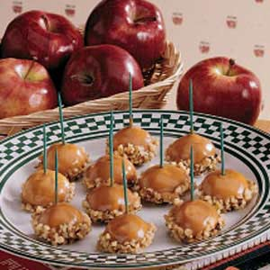
Caramel Apple Bites

Ingredients

- FILLING:
- ⅓ cup finely chopped unpeeled apple
- ⅓ cup evaporated milk
- ⅓ cup sugar
- ⅓ cup chopped walnuts

- DOUGH:
- ½ cup butter, softened
- ¼ cup confectioners’ sugar
- ¼ cup packed brown sugar
- 1 egg
- 1 teaspoon vanilla extract
- ¼ teaspoon salt
- 2 cups all-purpose flour
- TOPPING:
- 1 package (14 ounces) caramels
- ⅔ cup evaporated milk
- Green toothpicks
- 1 cup chopped walnuts

Instructions
- •In a small saucepan, combine filling ingredients. Cook and stir over medium heat until thickened; set aside to cool.
- • In a large bowl, cream butter and sugars until light and fluffy. Beat in egg. Beat in vanilla. Combine flour and salt. Gradually add to creamed mixture and mix well.
- • Shape dough into 1-in. balls. Flatten and place ¼ teaspoon filling in center of each. Fold dough over filling and reshape into balls. Place 1 in. apart on greased baking sheets.
- • Bake at 350° for 12-15 minutes or until lightly browned. Remove to wire racks to cool.
- • In a small saucepan over low heat, cook caramels and evaporated milk until caramels are melted; stir until smooth. Insert a toothpick into each cookie and dip into caramel until completely coated; allow excess to drip off. Dip bottoms into nuts. Place on wire racks to set. Yield: about 3 dozen.

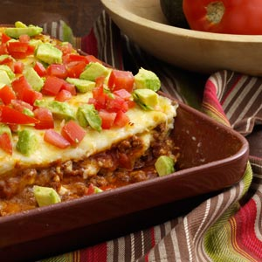
Texas-Style Lasagna Recipe

Ingredients
•1½ pounds ground beef
•1 tsp. seasoned salt
•1 package taco seasoning
•1 (14½ oz) diced tomatoes, undrained
•1 can (15 oz) tomato sauce
•1 can (4 oz) chopped green chilis
•2 cups (16 oz) cottage cheese
•2 eggs lightly beaten
•12 corn tortillas (6 inch) torn
•4 cups shredded monterey jack cheese
•crushed tortillas (optional)
•salsa (optional)
•cubed avocados (optional)

Instructions
In a large skillet cook ground beef until no longer pink. Add seasoned salt, taco seasoning mix, tomatoes, tomato sauce, and chilis. Reduce heat and simmer, uncovered for about 15-20 minutes.
In a small bowl combine the cottage cheese and eggs. Grease a 9×13 inch pan.
Layer half of the meat sauce in the bottom of the 9×13 pan. Next, layer half of the torillas, them cottage cheese, and half of the cheese. Repeat layers ending with cheese.
Bake uncovered at 350 for 30 minutes or until bubbly. Let stand 10 minutes before serving. Garnish with optional toppings.
Serve immediately or before baking, cover and freeze up to 3 months.

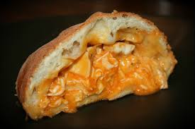

Buffalo Chicken Garbage Bread
2 boneless chicken breasts
1 tsp. olive oil
1 pizza dough (I used store bought and let it sit out for about 20 minutes)
8 oz. of shredded mozzarella cheese (I used part skim)
3 oz. of shredded cheddar cheese
1/2 cup of Franks Wing Sauce
1/3 cup of ranch or blue cheese dressing

Directions
Cut chicken into cubes. Season with salt and pepper. Heat teaspoon of olive oil in skillet and add chicken when hot. Cook chicken completely and then add 1/4 cup of wing sauce. Stir to coat chicken and let simmer for a minute or two. Take chicken off heat and let cool.

Pre-heat oven to 425°F.**
On a well floured surface, spread pizza dough into a long rectangle shape.

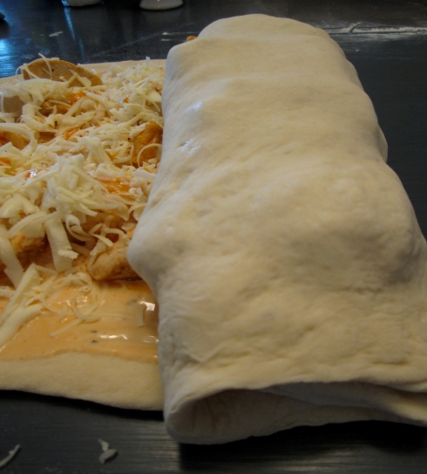
Add ranch dressing or blue cheese dressing (depending on your preference!) and remaining 1/4 cup of wing sauce. Spread across the dough. Add chicken and then top with mozzarella and cheddar cheese. You can also add a bit more of the wing sauce on top of the cheese if you want it to be a little bit spicier.

Roll the dough like a pinwheel until you reach the end. Make sure to tuck the ends of the dough in so the middle doesn’t ‘ooze’ out when baking.

Spray baking sheet with light coat of non-stick cooking spray. Place garbage bread on the pan and bake for 20 to 25 minutes.

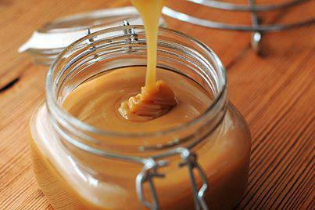
Amazing Caramel Sauce
I love a tablespoon of this added to my coffee and nothing more,
or on ice cream, or for dipping apples, the possibilities are endless!
Recipe yields 1 1/2 cups (although I usually double it but its just
as easy to only make a half batch)
1 cup packed brown sugar (I use light brown or golden)
1/2 cup heavy cream
4 tablespoons butter
Pinch of sea salt
1 tablespoon vanilla extract
Melt butter in pot, mix in brown sugar, cream and salt.
Cook over medium-low heat and whisk gently
for about 7 minutes or longer if you doubled.
I remove the pot from the heat, add vanilla and return to
cook for another minute or so to thicken a bit more.
Take it off the stove and pour into a jar then pop it into the
fridge and VOILA you're done!

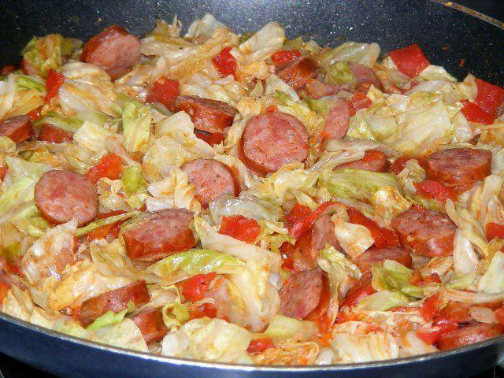
FRIED CABBAGE WITH SAUSAGE
This is a quick and easy dish and makes a meal served with cornbread.
1 stick butter or margarine
1 small head of cabbage, chopped
1 small onion, chopped
1 pound polish sausage, sliced into round pieces (I use smoked sausage)
1 (15 ounce) can diced tomatoes
1/2 teaspoon salt
1/2 teaspoon pepper
1/4 of green pepper
few drops of hot sauce (optional)
Add Potatoes (optional)
Melt butter in large skillet. Add cabbage, onion, and green pepper and cook on medium high for about 5 minutes stirring to keep from sticking to pan. Add remaining ingredients, cover and simmer for 20 – 25 minutes.
Makes about 8 servings.

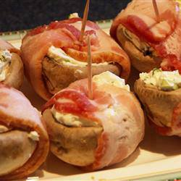
Bacon Wrapped Stuffed Mushrooms
Ingredients
1/2 cup chopped green onions
2 (8 ounce) packages cream cheese, softened
20 fresh mushrooms, stems removed
1 pound sliced bacon, cut in half
Directions
Preheat the oven to 350 degrees F (175 degrees C).
In a medium bowl, mix together the green onions and cream cheese . Stuff mushroom caps with the cheese mixture. Wrap each mushroom with a half-slice of bacon, and secure with toothpicks. Place on a baking sheet.
Bake for 20 minutes in the preheated oven, until the bacon is cooked through.

COPYCAT CHICK-FIL-A NUGGETS & HONEY MUSTARD DIPPING SAUCE
INGREDIENTS
6 Chicken Breasts
1 Egg
1 Cup Milk
2 Cups Flour
¼ Powdered Sugar
1 Tbsp Salt
1 Tbsp Pepper
1 Tsp Paprika
Canola Oil
Directions
• In a medium bowl whisk the egg and stir in the milk.
• Trim any fat away from chicken and cut chicken into bite size pieces.
• Place chicken in milk mixture and cover; let it marinate for 2-4 hours in the fridge. This will make the chicken very nice and tender.
• In a gallon size re-sealable baggie combine flour, powdered sugar, salt and pepper.
• Seal and shake to combine.
• Place about 2 inches of oil in a medium deep pot.
• Over medium high heat (more towards the high side) heat oil until hot. If using a thermometer let the temperature reach 375°. If you don't have a thermometer, test the oil by dropping a few drops of water into it. You want it to sizzle and not pop too much. Adjust your heat if necessary.
• Using a fork or tongs, remove cut chicken from milk mixture and place in the flour mixture.
• Seal and shake until nuggets are completely coated.
• Place about a 6-8 nuggets into hot oil and let them cook until golden brown, turning half way through once the edge of your chicken starts to turn white, about 1 minute each side. Always double check to see if any chicken you make is cooked through. Just make a tiny cut to see if it's pink.
• Remove and drain on a paper towel.
• Repeat until all nuggets are cooked.
Honey Mustard Dipping Sauce
1/2 cup mayonnaise
2 Tablespoons yellow mustard
1 Tablespoon Dijon mustard
3 Tablespoons Honey
1/2 Tablespoon lemon juice
Combine all ingredients. Mix until smooth.

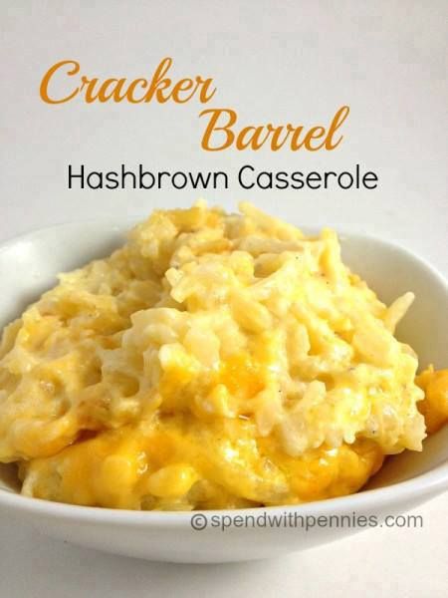
Cracker Barrel Hashbrown Casserole
32 oz. frozen shredded hash browns
1/2 cup melted butter
1 (10 1/4 ounce) can of cream of chicken soup
1 pint of sour cream
1/2 cup onion finely chopped
2 cups grated Colby cheese
1/4 teaspoon pepper
Instructions
Preheat oven to 350.
Mix all ingredients together.
Place in a greased 9x13 casserole dish.
Bake for 45 Minutes.

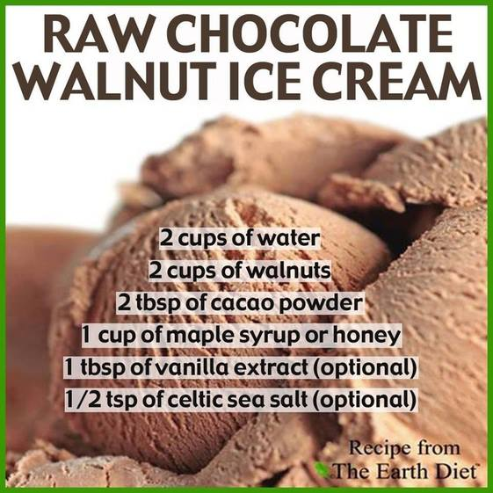
RAW CHOCOLATE WALNUT ICE CREAM
Makes one large tub for yourself or for sharing
INGREDIENTS:
2 cup of walnuts
2 cup of water
1 cup of maple syrup or honey
2 tablespoons of cacao powder
1 tablespoon of vanilla extract (optional)
1/2 teaspoon of himalayan or celtic sea salt (optional)
ACTION:
Either use an ice cream maker, Vitamix or High Speed Blender.
1. On high speed mix all ingredients until smooth fluffy ice cream like consistency.
2. Place in the freezer overnight!
TIP: Freeze for a few hours and then process again in the blender to make it even creamier!
+ ADD EXTRA cacao if you like super CHOCOLATE, add extra maple syrup if you like SUPER SWEET!
+ To replace the nuts (for nut allergies) use hemp seeds or sunflower seeds.
DAIRY FREE. REFINED SUGAR FREE. SOY FREE. GLUTEN FREE.
CHEMICAL FREE. ARTIFICIAL ANYTHING FREE. PROVIDES BODY NUTRITION.

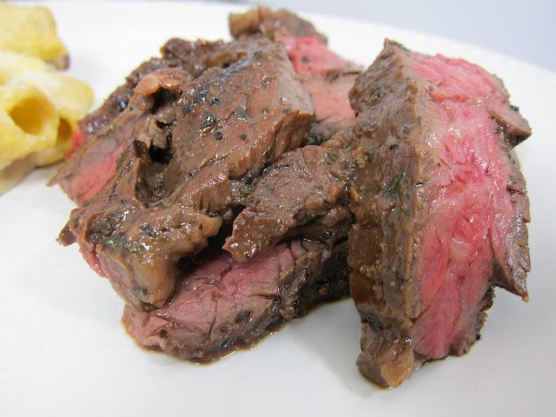
~BEST STEAK MARINADE IN EXISTENCE~
Ingredients
1/3 cup soy sauce
1/2 cup olive oil
1/3 cup lemon juice
1/4 cup Worcestershire sauce
1 1/2 Tbsp garlic powder
3 Tbsp dried basil
1 1/2 Tbsp dried parsley flakes
1 tsp ground white pepper
1/8 tsp cayenne pepper
1 tsp minced garlic
Directions
Combine all ingredients. Pour marinade over meat. Cover, and refrigerate for up to 8 hours. Cook meat as desired.

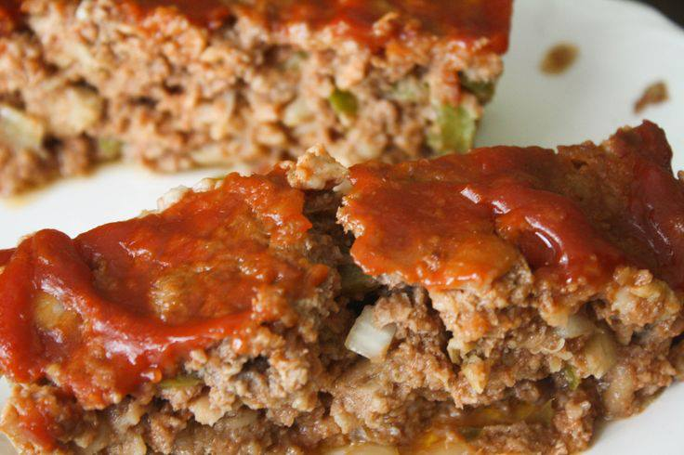
MISS MARY BOBO'S MEATLOAF –
From Miss Mary Bobo’s Boarding House Cookbook
1 ½ pounds ground beef
3/4 cup uncooked oatmeal
1 ½ tsp salt
¼ cup onions, chopped
¼ cup bell pepper, chopped
¼ cup catsup
2 eggs, beaten
Dash Worcestershire sauce
Dash onion powder
Dash garlic powder
Grease 9X3" loaf pan. In a large bowl combine all the ingredients and form into a loaf. Place in prepared pan. Bake for 1 hour in a preheated oven at 350. Pour off the juice and bake another 10 minutes longer. Place on a platter and cover with sauce.
Sauce
¾ cup catsup
2 Tbs onion, finely chopped
2 Tbs bell pepper, finely chopped
¼ cup brown sugar, firmly packed
1 Tbs Worchestershire sauce
1 Tbs vinegar

In a small saucepan simmer all ingredients over low heat until onion and pepper are tender.
Yield: 6 to 8 servings

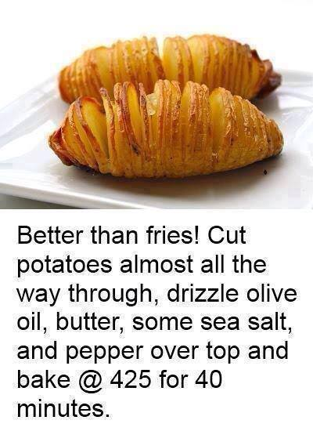

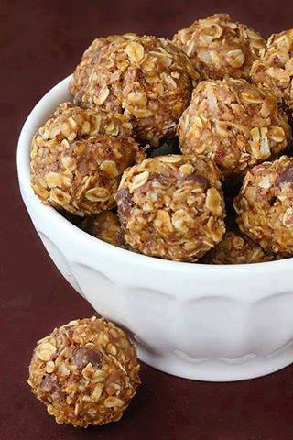
*~*~*No Bake Energy Bites*~*~*
So healthy!! And SO easy! And SO yummy!
1 cup (dry) oatmeal
1/2 cup chocolate chips
1/2 cup peanut butter
1/2 cup ground flaxseed
1/3 cup honey
1 tsp. vanilla
Mix ingredients together in a large bowl. Roll into bite size balls. Refrigerate to set. Enjoy!!

ADORABLE DR SEUSS COOKIES
1 17.5-oz. bag Betty Crocker Sugar Cookie Mix, mixed according to package directions
(or your favorite sugar cookie dough recipe)
Liquid food coloring, as desired (McCormick Neon shades work well)
Rainbow sprinkles, if desired
Preheat oven to 350°F. Divide dough evenly into five bowls, and color each with a different color liquid food coloring. Roll each color of dough into grape-sized balls. Combine a ball of each color and quickly roll into a larger ball. It will look like a little beach ball. Then roll that ball between your hands and the counter until you have a cylinder about 12 inches long. Starting from one end, roll the dough into a coil, twisting the cylinder as you go. Roll edges of the cookie in sprinkles. Bake the cookies for 10 to 11 minutes, or until done.
Yields: approximately 3 dozen cookies

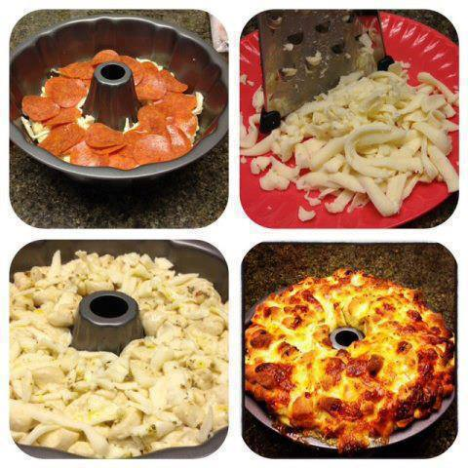
Pepperoni and Mozzarella Pull Apart Bread
Ingredients
1/3 cup favorite flavored dipping oil
2 teaspoons garlic powder
2 (16 ounce) pkgs pre-made pizza dough or homemade pizza dough
1 (7 oz) pkg sliced pepperoni
1 (8 oz) pkg shredded mozzarella cheese
Directions
1. Preheat oven to 375 degrees F
2. Separate pizza dough into small bite sized pieces.
3. In a bowl add your favorite flavored dipping oil. Toss dough pieces in dipping oil to lightly coat.
4. Layer dough pieces in bottom of bundt or fluted tube pan, next layer sliced pepperoni, shredded cheese and sprinkle with garlic powder. Repeat layers again, and end with final layer of dough pieces.
5. Bake in the preheated oven until the bread is browned and cooked through in the center, 30-40 min
6. Remove from oven, and invert the pan on a cutting board; the bread will fall out of the pan in one piece.
7. Serve by pulling the bread apart into individual servings with optional marinara dipping sauce on the side.
I usually layer until about 2/3 of the pan is full. Definitely plan for it to feed a hungry crowd. You can scale down the ingredients if you choose to feed a smaller crowd. You can serve it hot or room temperature —

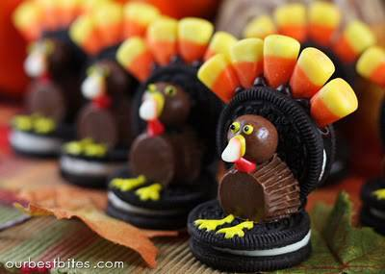
Oreo Turkeys
Here is what you will need:
Double Stuff Oreo Cookies
Candy Corn
Whoppers
Peanut butter cups
Chocolate frosting
Yellow Frosting
Optional: Red frosting
Optional: black sprinkles for eyes
Steps to make your Turkey:
1) Grab a cookie and put a tiny bit of frosting inside, this will help hold the candy corn a bit better!
2) Insert your candy corn. It seems that 5 candy corns, smaller tips inserted into the cream center works best.
3) Put a dab of frosting on the opposite end of the cookie from where you just inserted the candy corn, and then secure the cookie to the “base” cookie. Placing the cookies against the wall while they dry may help them keep their shape better!
4) While your cookies are drying open a peanut butter cup (have a parent do this part kids!) – and cut a sliver off of one end.
5) Once your cups are ready, flip your cookies over, but still keep them next to the wall in case the frosting is not completely dry yet. Place a dab of frosting on peanut butter cup and place it on the cookie as shown below.
6) For the heads you will put a dab of frosting on a whopper and attach it to the top of the peanut butter cup.
7) Use a dab of frosting and flue on a white tip of a candy corn for a beak, put 2 yellow dots for eyes and if you would like a smaller black dot for the center of the eye. (You can use frosting, a sprinkle, a mini chocolate chip for the black part of the eye).
Once the beak stays put and everything seems to be sturdy, you can stand these cute little guys up and draw on some little feet if you would like. You can even add a little thingie under the neck!
To be extra creative and use them as place card holders, create your place card, adhere it to a toothpick and you can insert that into the center of the cookie!

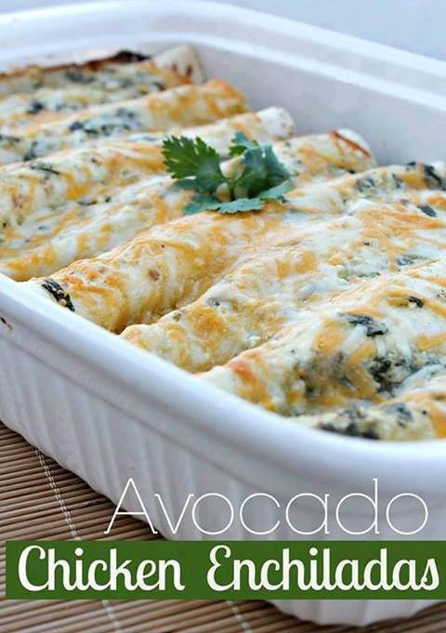
Avocado Chicken Enchiladas
Ingredients for the Enchilada Sauce
1 tablespoon butter
3 garlic cloves, minced
1 tbsp flour
1 cup chicken stock - (you could use vegetable stock)
2 teaspoons of cumin
1/4 teaspoon salt
1/4 teaspoon fresh ground pepper
1/2 cup chopped cilantro
1 cup mild or medium salsa verde
1/2 cup fat free sour cream
Ingredients for the Enchiladas
3-4 cups cooked chicken breasts, chopped or shredded
2 cups shredded Mexican blend cheese
3 avocados, peeled and chopped
8 flour tortillas
Directions
1. Preheat oven to 375 degrees. In medium sauce pan, saute garlic in butter for about 1 minute on Medium – High Heat. Stir in flour let it cook for about 2 more minutes.
2. Next stir in the chicken broth, cumin, salt, pepper and bring to a simmer. Remove from heat and stir in the sour cream, salsa verde and cilantro until smooth (or at least as smooth as you can get.)
3. Prepare a 9×13 baking dish with nonstick spray. Add about 1/2 cup sauce to the bottom of the pan. and spread out until bottom of the baking dish is evenly coated.
4. Lay out a tortilla and add chicken, shredded cheese, and avocado to the end of the tortilla and roll. Then place the rolled tortilla seam-side down and repeat until the pan is full.
5. Pour the remaining sauce over the enchiladas. Cover with 1 cup of cheese and bake for about 20 minutes or until cheese is bubbling.

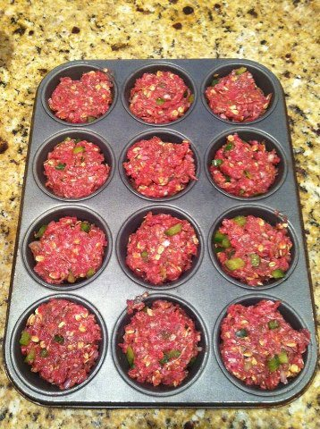
Make meatloaf in a muffin pan
Ingredients
1 2/3 to 1 3/4 pounds ground sirloin
1 medium onion, cut into chunks
2 ribs celery from the heart of the stalk, cut into 2-inch pieces
1 green bell pepper
1 large egg plus a splash of milk, beaten
1 cup plain bread crumbs
2 tablespoons grill seasoning (recommended: Montreal Steak Seasoning by McCormick)
1 cup smoky barbecue sauce
1/2 cup tomato salsa
1 tablespoon Worcestershire sauce
Vegetable oil or extra-virgin olive oil
Directions
Preheat oven to 450 degrees F.
Put ground beef into a big bowl. Put onion and celery into a food processor. Cut the bell pepper in half, rip out the seeds and throw them into your garbage bowl. Cut the pepper into a few pieces and add to the food processor. Pulse the processor blades to finely chop the vegetables into very small pieces then add them to the meat bowl. Add egg, beaten with milk, bread crumbs and grill seasoning to the bowl. Next, mix together the smoky barbecue sauce, the salsa and the Worcestershire sauce. Pour half the sauce mixture into the bowl with the meatloaf mix. Mix the meatloaf together with your hands. Wash up. Brush a 12-muffin tin (1/2-cup each) with vegetable oil or extra-virgin olive oil. Use an ice cream scoop to help you fill meat into a each tin. Top each meat loaf with a spoonful of extra sauce. Bake about 20 minutes. Cut open 1 muffin to test that the middle is cooked through,

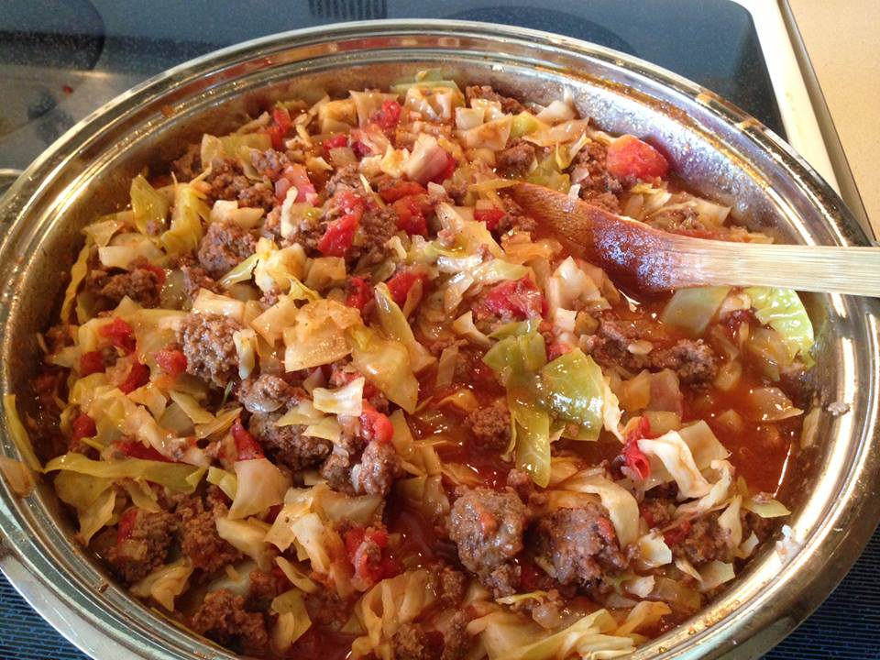
UNSTUFFED CABBAGE ROLLS
Cabbage is a superfood with lots of nutrients! Among many other health benefits, it is known for healing stomach ulcers and preventing cancer --especially colon cancer. It is a very alkaline forming food. Eat it often!
Ingredients:
1 1/2 to 2 pounds lean ground beef or turkey
1 tablespoon oil
1 large onion, chopped
1 clove garlic, minced
1 small cabbage, chopped
2 cans (14.5 ounces each) diced tomatoes
1 can (8 ounces) tomato sauce
1/2 cup water
1 teaspoon ground black pepper
1 teaspoon sea salt
Preparation:
In a large skillet, heat olive oil over medium heat. Add the ground beef and onion and cook, stirring, until ground beef is no longer pink and onion is tender.
Add the garlic and continue cooking for 1 minute.
Add the chopped cabbage, tomatoes, tomato sauce, pepper, and salt. Bring to a boil. Cover and simmer for 20 to 30 minutes, or until cabbage is tender.
Yield: Serves 6 to 8

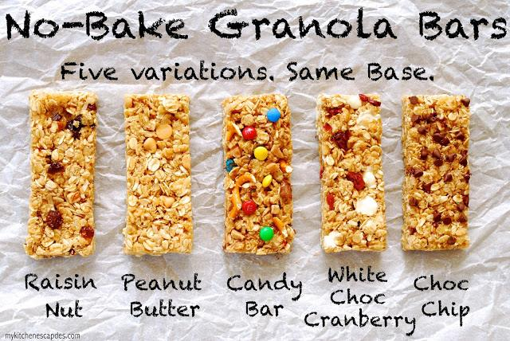
No-Bake Chewy Granola Bars
(recipe makes a 9x13 pan)
2 cups quick cooking oats (or pulse whole oats in a food processor a bit)
1 C rice crispy cereal
1/4 C shredded coconut
1/4 C butter
1/4 C honey
1/2 C brown sugar
1/2 tsp salt
1/2 tsp vanilla
Mix -In variations listed below
1. In a large mixing bowl, mix together the oats, cereal and coconut. Set a small saucepan over medium high heat and melt the butter. Add the honey, brown sugar and salt. Stir together then leave it alone as it comes to a boil. Once the boil has reached all the way around the edges of the pan, begin timing. Allow this mixture to boil for 2 minutes and 15 seconds. During this time, you may need to turn the heat down a bit so it doesn't overflow, but be sure it keeps boiling.
2. Pour the mixture over the oats, using a rubber spatula to get all the sugar mixture out of the pan. Mix the ingredients together until the oats are completely coated. Add in your desired mix-in then press very firmly into a lightly greased 9x13" pan. If you like your bars thicker, you can use a smaller pan. If you do not press firmly enough, the bars will fall apart when you eat them. Place them in the fridge for 20 minutes then cut to size.
Chocolate Chip
Add 1/2 C of mini chocolate chips to the finished mixture before pressing into the pan, allowing it cool just a bit or you will end up with melted chips. Sprinkle on a few extra chips over the top after they are pressed into the pan.
White Chocolate Cranberry
Add 1/3 C of white chocolate chips and 1/3 C of Craisins to the finished mixture before pressing into the pan, allowing it to cool just a bit first or you will end up with melted chips.
Candy Bar
Add 1/3 C of Heath bar pieces, 1/3 C of mini M&M's and 1/3 C of chopped pretzels to the finished mixture before pressing into the pan.
Peanut Butter
Add 2 Tb of peanut butter to the finished sugar mixture before pouring it over the oats. Once mixed with the oats, add 1/2 C peanut butter chips before pressing into the pan.
Raisin Nut
Add 1/3 C of chopped raisins and 1/3 C of chopped pecans to the finished mixture before pressing into the pan.

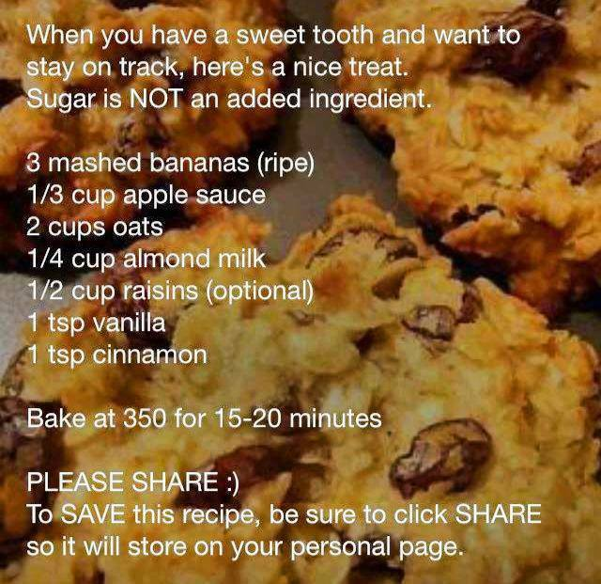
Sounds delicious AND they are egg-less, dairy-less, flour-less, and with no added sugar!

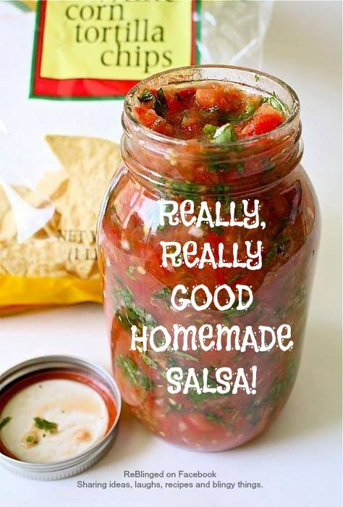
REALLY, REALLY GOOD SALSA And easy! NO COOKING!
(Once you taste this recipe, you'll never buy salsa again)!
3 cups chopped tomatoes
1/2 cup chopped green bell pepper
1 cup onion, diced
1/4 cup minced fresh cilantro
2 tablespoons fresh lime juice
4 teaspoons chopped fresh jalapeno pepper (including seeds)
1/2 teaspoon ground cumin
1/2 teaspoon kosher salt
1/2 teaspoon ground black pepper
Stir all ingredients together. Refrigerate. Best to let marinate overnight. But several hours will suffice, if you can't wait to dig in! Serve chilled.

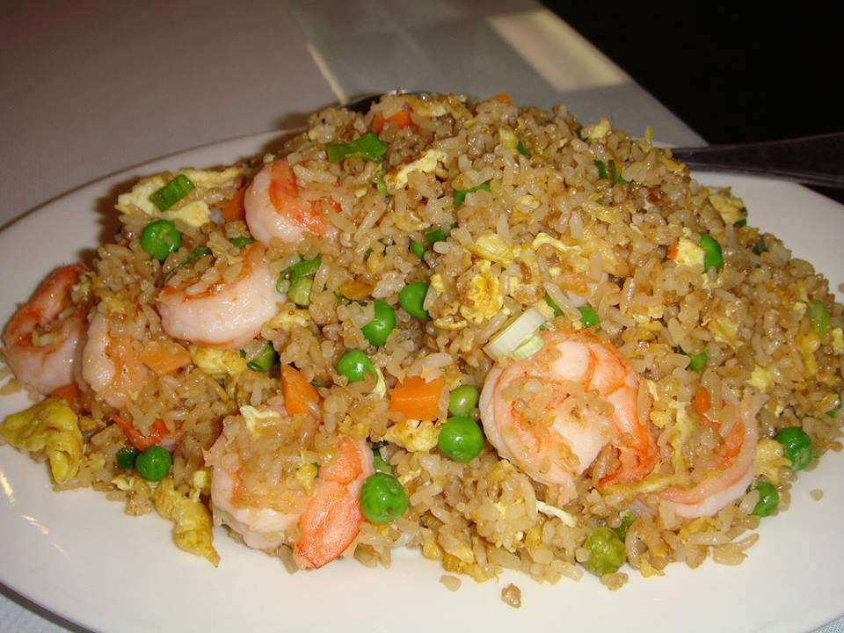
BETTER-THAN-TAKEOUT-FRIED-RICE
Serves: 5-6
Ingredients
•4 cups rice, prepared
•½ pound boneless, skinless chicken breasts, cooked or shrimp cooked
•1 cup peas & carrots, frozen
•1 white onion, chopped
•2 cloves garlic, minced
•2 eggs
•3 tablespoons sesame oil
•¼ cup soy sauce
Instructions
1.Prepare rice according to package instructions to yield 4 cups cooked rice.
2.Heat sesame oil in a large skillet on medium heat.
3.Add onion, garlic, peas, and carrots. Stir fry until tender.
4.Crack eggs into pan and scramble, mixing throughout vegetables.
5.Add rice, chicken, and soy sauce to pan. Stir in soy sauce and remove from heat.

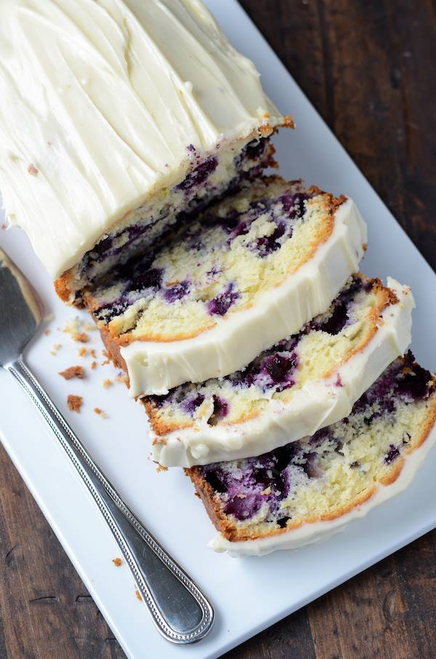
Blueberry Lime Cream Cheese Pound Cake
Ingredients:
1 1/4 cups all-purpose flour
1 teaspoon baking powder
1/4 teaspoon salt
1 stick (1/2 cup) unsalted butter, room temperature
4 oz PHILADELPHIA cream cheese, room temperature
2/3 cup granulated sugar
2 large eggs
1 tablespoon vanilla extract
2 tablespoons lime zest
1 cup fresh blueberries
PHILADELPHIA cream cheese frosting:
4 oz cream cheese, room temperature
4 tablespoons unsalted butter, room temperature
1 1/2 cups powdered sugar
1 teaspoon vanilla extract
Directions:
Preheat oven to 350°F. Butter a 9 x 5 loaf pan. Line the bottom of the pan with parchment paper and butter the parchment paper as well. Set aside.
In a medium bowl, whisk together flour, baking powder and salt. Set aside.
In stand mixer, beat together cream cheese, butter and sugar until light and fluffy, about 2 minutes. Add eggs one at a time, thoroughly mixing each time. Add vanilla extract and lime zest, mixing until combined.
Pour flour mixture over the batter mixture. Using a large rubber spatula, gently fold in the flour until it’s completely mixed in and there are no pockets of dry flour. Lastly, gently fold in the blueberries.
Transfer batter to prepared baking loaf pan. Bake for 55-65 minutes, or until toothpick inserted in the center comes out clean. Let sit until cool, at least 30 minutes and then remove from pan.
In a stand mixer or large bowl, cream butter and cream cheese until smooth. Add confectioners' sugar and beat on low speed until combined, then on high until frosting is smooth. Beat in vanilla extract.
Carefully frost on top of the cooled pound cake and store in fridge until ready to serve.

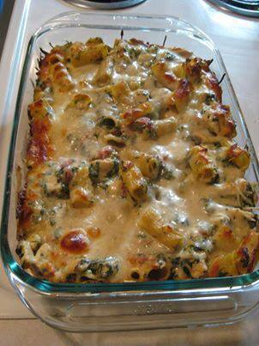
Chicken & Spinach Pasta Bake
Ingredients
8 oz uncooked rigatoni
1 T olive oil
1 c chopped onion
1 (10 oz) pack frozen spinach, thawed
3 c cubed, cooked chicken breasts
1 (14 oz) can Italian-style diced tomatoes, undrained
1 (8 oz) container Philadelphia chive & onion cream cheese
½ t salt, ½ t pepper
1½ c shredded mozzarella cheese
Prepare rigatoni according to pkg directions. Spread oil on bottom of 11×7 in baking dish; add onion in a single layer. Bake at 375 for 15 minutes or just until tender. Transfer onion to large bowl, set aside.
Drain chopped spinach well, pressing between paper towels. Stir in rigatoni, spinach, chicken, & next 4 ingredients into onion in bowl. Spoon mixture into dish & sprinkle evenly with shredded mozzarella cheese. Bake covered at 375 for 30 minutes; uncover & bake 15 more minutes or until bubbly.

Candy Sleighs:

Hot glue gun,
1 standard Kit Kat bar,
2 candy canes,
10 Hershey bars (stacked 4, 3, 2, 1),
ribbon

& a bow on top!

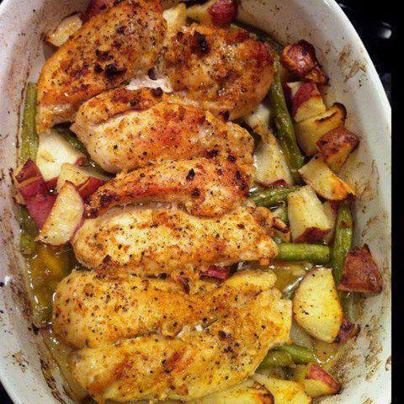
GARLIC & LEMON CHICKEN W/GREEN BEANS & RED POTATOES!
(Gluten free, Low Carb, Diabetic Friendly and so simple to make)
INGREDIENTS
6 tablespoons olive oil
2 lemons, 1 thinly sliced, 1 juiced
4 cloves garlic, minced
1 teaspoon salt
1/2 teaspoon freshly ground black pepper
3/4 pound trimmed green beans
8 small red potatoes, quartered
4 chicken breasts (bones left in, with skin, about 3 1/4 pounds)
DIRECTIONS
Preheat oven to 400°F. Coat a large baking dish or cast-iron skillet with 1 tablespoon of the olive oil. Arrange the lemon slices in a single layer in the bottom of the dish or skillet.
In a large bowl, combine the remaining oil, lemon juice, garlic, salt, and pepper; add the green beans and toss to coat. Using a slotted spoon or tongs, remove the green beans and arrange them on top of the lemon slices. Add the potatoes to the same olive-oil mixture and toss to coat. Using a slotted spoon or tongs, arrange the potatoes along the inside edge of the dish or skillet on top of the green beans. Place the chicken in the same bowl with the olive-oil mixture and coat thoroughly. Place the chicken, skin-side up, in the dish or skillet. Pour any of the remaining olive-oil mixture over the chicken.
Roast for 50 minutes. Remove the chicken from the dish or skillet. Place the beans and potatoes back in oven for 10 minutes more or until the potatoes are tender. Place a chicken breast on each of 4 serving plates; divide the green beans and potatoes equally. Serve warm.

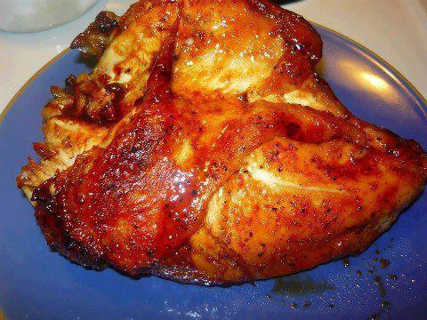
3 INGREDIENT CHICKEN!!!
1) CHICKEN
2) PACKET DRY ITALIAN SEASONING MIX
3) 1/2 CUP BROWN SUGAR
MIX THE ITALIAN SEASONING PACKET AND THE BROWN SUGAR.......COAT CHICKEN ON ALL SIDES.....LINE PAN IN FOIL BECAUSE THE DRESSING/SUGAR WILL CARAMELIZE.....BAKE AT 350 DEGREES UNTIL IT'S GOLDEN BROWN...25 MINUTES ON EACH SIDE.....

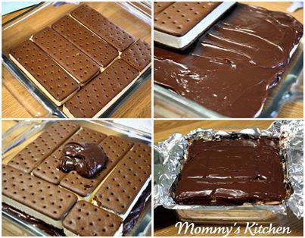
Ice Cream Sandwich Cake
11 - Great Value - vanilla, chocolate, neapolitan or strawberry ice cream sandwiches
1 - 16 oz container Great Value whipped topping (cool whip)
1 - 16 oz jar Hershey's hot fudge ice cream topping
1 - cup chocolate chips, whoppers candies, oreo cookies, m&m's, chocolate chips, festive sprinkles, heath bar bits, peanut butter cups or crushed butterfingers
Hershey's chocolate syrup for garnish
chocolate or colored sprinkles for garnish
Directions:
Layer a 8 x8 in pan with foil. Make sure the foil lays over the sides of the pan. This will make it easier to remove the ice cream cake from the pan when frozen.
Layer 5 1/2 ice cream sandwiches on the bottom of the pan. Spread a layer of hot fudge topping on top of the ice cream sandwiches. Then spread half of the cool whip on top of the fudge topping.
Repeat the same process with the second layer ending with hot fudge. Cover with plastic wrap and freeze for about one hour. Remove from freezer and remove the ice cream cake from the pan.
Lift the cake peeling it off of the foil and place it onto a serving plate. Frost with additional cool whip.
Drizzle on some Hershey's chocolate syrup and garnish with chocolate chips and sprinkles or the candy toppings of choice.
Place the ice cream cake back into the freezer and freeze for 2 hours.

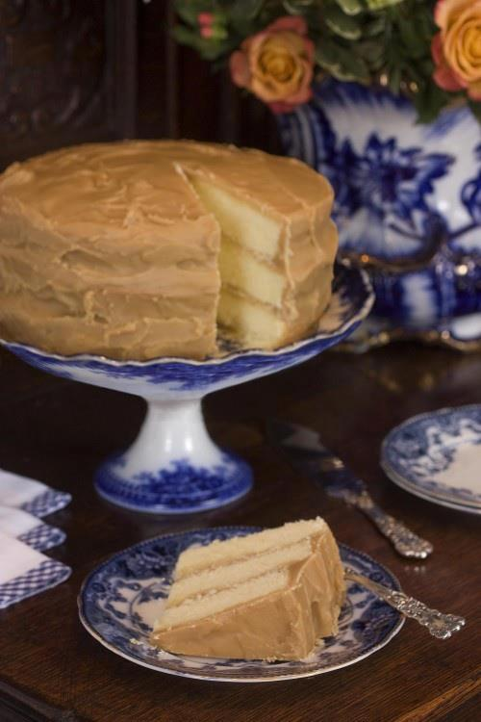
Caramel Cake:
Ingredients:
3 sticks butter
3 cups sugar
5 eggs
3 1/2 cups all-purpose flour
1/4 teaspoon salt
1/2 teaspoon baking powder
1 1/4 cups whole milk
1 teaspoon vanilla
Directions: Preheat your oven to 350 degrees. Cream the butter, sugar and eggs together and beat well. In a separate bowl, combine dry ingredients. Add the dry ingredients alternately with the milk, and then add vanilla. Beat in a mixer bowl or with a hand mixer until the batter “ribbons.” Pour batter into three greased and floured 9-inch cake pans. Bake for about 30 minutes and use a toothpick to check to see if it is done. This cake can also be made in a 9-inch x 13-inch pan, which will need to be baked for about 45 minutes. Cool layers on a cake rack before icing.
Caramel Icing
Ingredients:
2 sticks butter
1 (16 oz.) box of light brown sugar
1/4 teaspoon salt
2/3 cup evaporated milk (canned)
2 cups sifted confectioner’s sugar
2 teaspoons pure vanilla extract
Directions: Place butter, brown sugar and salt in a saucepan. Heat, stirring until the brown sugar is well dissolved. Add milk and continue stirring until blended. Let bubble (at an easy boil) for approximately 4 minutes. Stir constantly to avoid sticking. Set hot mixture aside to cool for several minutes. Using mixer, add confectioner’s sugar and vanilla. You will see it turn lighter and caramelize. When you’ve reached the desired consistency, ice the cake, placing some of the icing between the layers.

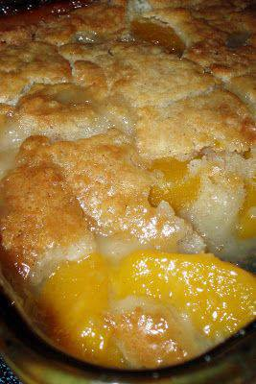
Peach Cobbler
2 cups fresh sliced peaches (or one 29 ounce can of sliced peaches, drained)
1 cup Bisquick mix (or make your own mix, see below)
1 cup of milk
1/2 teaspoon nutmeg
1/2 teaspoon cinnamon
1/2 cup butter, melted
1 cup of sugar
Preheat oven to 375 degrees. In an 8 x 8 baking dish, stir Bisquick mix, milk, nutmeg and cinnamon together until thoroughly mixed. Stir in melted butter.
In a medium mixing bowl, stir sugar and peaches. Spoon peaches over the cobbler crust.Bake for one hour or until crust is a golden brown. Serve warm and enjoy!

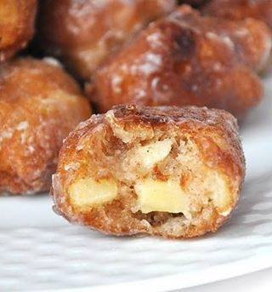
Homemade Apple Fritters Recipe:
1 heaping cup all purpose flour
1/3 cup sugar
1 tsp. baking powder
dash salt
1 - 2 tsp. cinnamon (depending on how much you love cinnamon)
1/4 tsp. nutmeg
1/2 tsp. vanilla
1 T. butter, melted
1 egg
1/3 cup milk + plus more if needed
1 - 1 1/2 cups chopped apple
oil for frying
milk and powdered sugar glaze for dipping or just powdered sugar for dusting
(About 1 cup powdered sugar + 1 T. milk or more)
Mix all dry ingredients together, slowly add the wet ingredients minus the apple. Carefully mix until well combined. Gently fold in apple pieces. The batter should be the consistency of a light cake mix. Once the oil is read (when a test drop of dough floats to the top of the oil) then using a cookie scooper or soup spoon, place a few balls of dough into the oil. Be careful not to overcrowd and watch carefully for the underside to turn golden brown, then gently flip over and continue frying until done. Cook about 45 seconds per side, adjust cooking times based on size of fritters and temperature of your oil. It is always a good idea to test one to ensure it comes out like you are expecting.

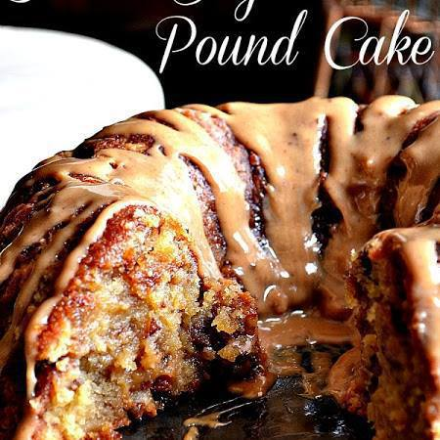
Brown Sugar Carmel Pound Cake
Ingredients:
1 ½ cups butter softened
2 cups light brown sugar, packed
1 cup granulated sugar
5 large eggs
3 cups all-purpose flour
1 teaspoon baking powder
½ teaspoon salt
1 cup whole milk
1 8oz bag toffee chips
1 cup pecans, chopped
Carmel Drizzel:
1 – 14 oz can sweetened condensed milk
1 cup brown sugar
2 tablespoons butter
½ teaspoon vanilla extract
Directions:
Preheat oven to 325 spray a 12 cup Bundt pan with cooking spray with flour
Beat butter until creamy. Add sugars beating until fluffy. Add eggs one at a time. In medium bowl combine flour, baking powder and salt. Add flour mix to batter alternately with milk, beat until just combined. Stir in toffee buts and pecans. Spoon batter into pan and bake 85 minutes or until wooden pick comes out clean. To prevent excess browning, cover cake with foil while baking.
Let cake cool in pan for 10 minutes. Remove from pan, and let cool completely on a wire rack. Spoon Caramel Drizzle over cooled cake.
Directions for Caramel Drizzle
In a medium saucepan, combine condensed milk and brown sugar; bring to a boil over medium-high heat, whisking frequently. Reduce heat, and SIMMER for 8 minutes, whisking frequently. Remove from heat; whisk in butter and vanilla. Let cool for 5 minutes before using. NOTE: Make sure you drizzle the caramel while it’s still HOT. When cooled the caramel does somewhat harden.

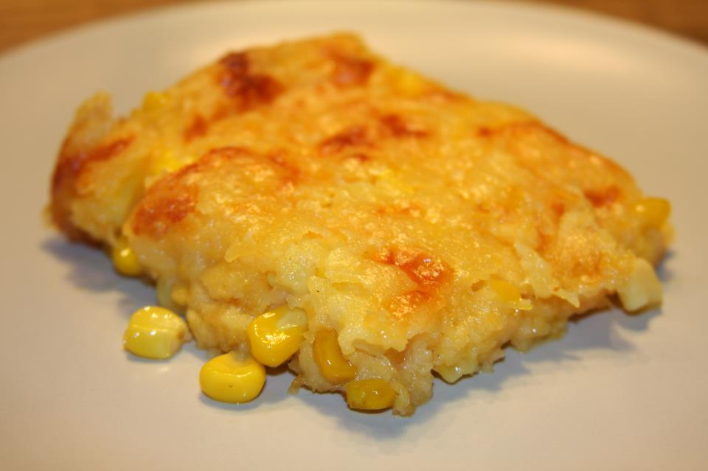
Corn Casserole
1 (15oz) can whole kernel corn, drained
1 (15oz) can cream-style corn
1 package Jiffy corn muffin mix (8 oz.)
1 cup sour cream
1/2 cup butter, melted
1 cup shredded cheddar cheese or your favorite
Preheat oven to 350 degrees. mix all ingredients, minus the cheese, together and pour into a greased baking dish. After the casserole has baked for 45 minutes, or is set in the middle and golden brown, sprinkle with cheddar and put it back in the oven. Let the cheese melt, take the casserole out and enjoy this ridiculously buttery dish.

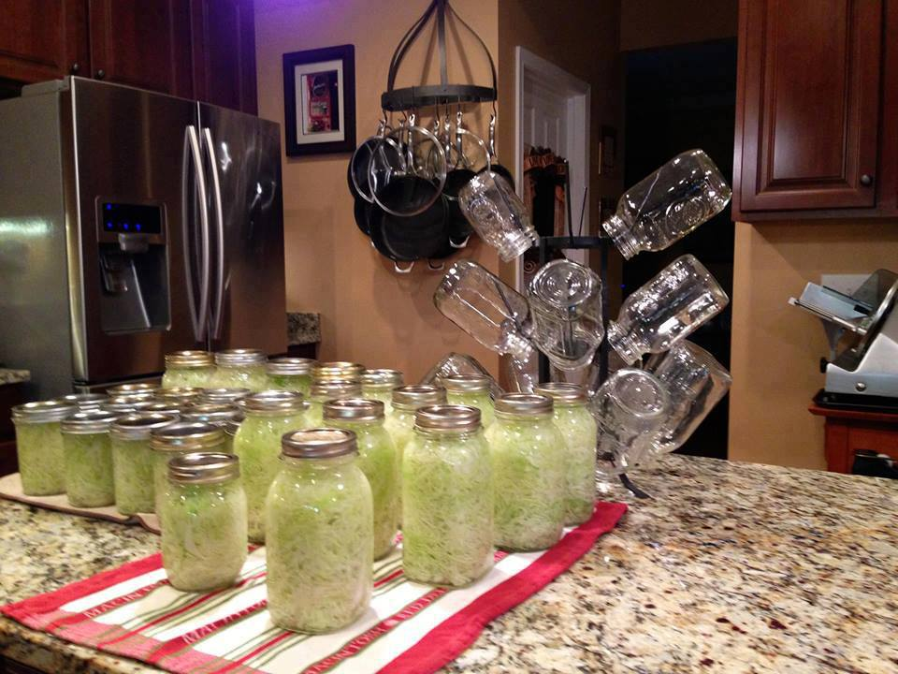
Home Made Sauerkraut
10 quarts & 1 pint of regular ~ 4 quarts & 14 pints of garlic.
Cabbages
Canning/Kosher Salt
Honey
Boiling Water
Heads of Fresh Garlic**
Slice/shred the cabbages.
Using a wooden spoon pack the cabbage tightly into prepped canning jars but leave about a half-inch of space at the top.
Place 1 teaspoon of canning/Kosher salt & 1/2 teaspoon honey on top of each quart.*
Pour enough boiling water into each jar to completely cover the cabbage.
Use the wooden spoon handle to work out air bubbles in the jar.
Place a hot jar lid on top & screw a band on just fingertip tight, and set on the countertop overnight ~ check for a good seal before moving them to a dark place that is about 65-70 degrees F.
If you find one or two that haven't sealed take off the lids pour the juice into a saucepan or microwave safe container, re-heat it to boiling, wash & rewarm the lids & bands, pour the juice over top & reseal. I only had 1 fail to seal out of this batch!
The jars may leak fermented cabbage juice, so be careful where you place them, and check them every few days. I keep mine on several layers of newspaper in the basement.
The kraut can be eaten after 2 weeks but is very sour.. we think it tastes much better if you wait 6 weeks.
*To make pints fill the jars and put 1/2 tsp canning salt & 1/4 tsp honey on top of cabbage before pouring the boiling water into the jar.
**To make garlic kraut just drop a a large clove or two of fresh garlic into the jar before before adding the cabbage.
Some people like to waterbath the kraut after 2 -3 months of storage but.. it destroys the probiotics & the woman who originally gave me this recipe (her family heirloom recipe uses sugar instead of honey) said her family cans enough to get through the entire year and has never waterbathed it. I have since seen this recipe online using honey because of it's antibacterial/natural preservative health qualities so I switched to it & haven't ever had a single jar spoil.

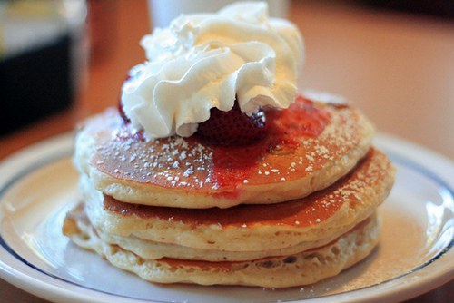
IHOP Cheesecake Pancakes

1 1/2 cups of strawberries
2 tbsp. seedless strawberry jam
1 1/4 cups flour
1 1/4 cups buttermilk
1 egg
1/4 cup vegetable oil
1/4 cup sugar
1 tsp baking powder
1 tsp baking soda
Whipped cream and powdered sugar
8 oz. cream cheese
1/2 cup graham cracker crumbs
Remove the outer edge of each strawberry, then slice lengthwise. Place strawberries in a bowl and set aside.
Cut an 8 ounce block of cream cheese into four long pieces. Lay the pieces on a cookie sheet and cover with foil. Place the cream cheese in a freezer for 8 hours.
Combine 1 1/4 cups of flour, 1 1/4 cups of buttermilk, 1 medium egg, 1/4 cup of vegetable oil, 1/4 cup of sugar, 1 teaspoon baking powder and 1 teaspoon baking soda in a blender. Pulse the mixture until it's smooth and creamy.
Remove the cream cheese pieces from the freezer and dice them into small, 1-inch cubes. Pour the pancake batter into a large mixing bowl and stir in 1/ cup of graham cracker crumbs and the cream cheese cubes. Mix the sliced strawberries, 2 tablespoons of strawberry jam, and the water in a small bowl. For best results, opt for a high-quality strawberry jam.
Spray a large skillet with nonstick cooking spray and place it over medium heat. Pour 1/4 cup of batter into the skillet for each pancake. When the cakes become bubbly on top, flip them over and cook the other side for about two minutes.
Pour the strawberry sauce mix over the finished pancakes.
Garnish pancakes with whipped cream and powdered sugar for a festive, restaurant-style touch.

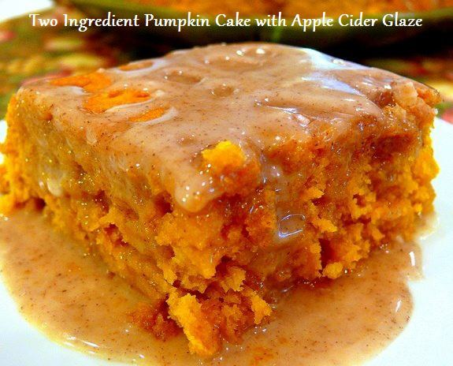
Pumpkin Cake with Apple Cider Glaze
For the Cake:
1 Yellow Cake Mix
1 15 ounce can of pumpkin puree
For the Glaze:
1-1/2 cups powdered sugar
3 Tablespoons apple cider
3/4 teaspoon pumpkin pie spice
Empty the contents of the boxed cake mix and pumpkin puree into a large bowl. Using a hand-mixer or stand mixer beat until well incorporated. The batter will be very thick, but will come together nicely.
Pour batter into a greased 7 x 11 X 2 pan. This is the small, rectangular-sized pan from your Pyrex set. You know the set you had to have when you got married and rarely ever used all the pieces. Finally, you have a use for it.
Bake at 350 degrees for 28 minutes or until a toothpick inserted in the center comes out clean. Do not over bake.
Let cool for 5-10 minutes in the pan, then flip onto a platter.
Make the glaze while you're waiting.
Combine powdered sugar, apple cider and pumpkin pie spice. Glaze should be thick but pourable. Add more sugar or cider if needed. Pour over the cake while still warm. Reserve some to pour over each slice when served.

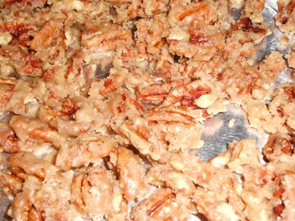
ICED PECANS
I found this recipe for ICED PECANS in an old Better Homes and Gardens magazine from the 60's. That's as old as me! Each pecan half is coated ("iced") with a thin coating or crust of candied sugar that reminds me of Louisiana pralines. Oh, so good! These are a wonderful holiday treat but I make them throughout the year as well! I usually make many batches to give as gifts. They're done in less than 10 minutes once you've got all your ingredients together.
3 cups pecan halves
1 cup white granulated sugar
Small pinch of salt
8 Tbsp. butter or margarine (1 stick)
1 tsp. vanilla
Line a baking sheet with foil. Lightly spray with cooking spray, and set aside. In a heavy skillet, use a wooden spoon to combine pecans, sugar, pinch of salt and margarine. Cook over medium heat, stirring constantly, for 9 minutes. Sugar will melt and turn a rich brown color. Watch out for spatters.
Remove from heat and immediately stir in vanilla extract. The vanilla extract being stirred into the hot pecan mixture will make your kitchen smell delicious! Be careful - the pan will be very hot. Spread mixture onto the prepared baking sheet and VERY LIGHTLY sprinkle with salt right away while they're still hot (optional). This tiny touch of salt balances out the sweet, buttery, vanilla flavor. Using 2 forks, separate pecans quickly before they cool and stick together; allow to cool completely. Stored tightly covered, they will keep for a week or two. They don't last that long at my house! They’re so good, you may need to reserve ("hide") a few for yourself!
Notes: Use only stick margarine for this recipe to be it’s best. Soft margarine in a tub DOES NOT work in this recipe.
While the pecans are cooling, fill the pan with hot, soapy water at let it sit for a few minutes. The pan should then be very easy to clean.
Walnuts, almonds, peanuts or just about any nut can be used in place of pecans. A (16 oz.) jar of lightly salted peanuts is the perfect amount for this recipe. We tried this recipe using peanuts last Christmas and they were a hit!
I've heard of others adding a touch of cinnamon or even cayenne pepper to recipes similar to this one, but I prefer the sweet, buttery, vanilla goodness this version adds to the pecans...but to each his own.
Go ahead and sample a few while they're still warm. You're going to want to experience that sweet, buttery, crunchy pecan goodness while it's still warm - just don't burn your mouth! Lol
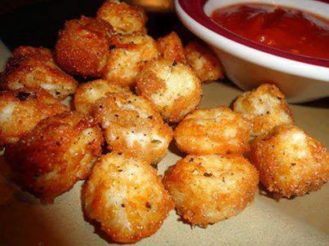
Baked Cheese Balls
Cut up string cheese, dip in skim milk, then Italian bread crumbs.
Bake at 425 for 7-10 minutes.
Yummy Dipped in Marinara Sauce!!!

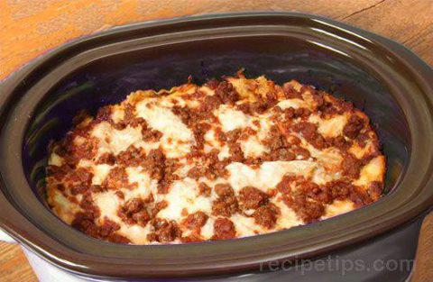
Crock Pot Lasagna
1 pound Ground Beef
Lasagna noodles
1 jar spaghetti sauce
1 1/2 cups cottage cheese
1 1/2 cups shredded Mozzarella cheese
2 tablespoons grated Parmesan cheese
Directions
Brown ground beef and drain. Spoon 1 C. spaghetti sauce in bottom of 4 quart crock pot. Mix remaining sauce with beef. Place 2 uncooked lasagna noodles on sauce in crock pot. Spread 1/3 meat mixture on top of noodles. Spread 3/4 C. cottage cheese over meat. Sprinkle 1/2 C. mozzarella cheese over cottage cheese. Add another layer of uncooked noodles, 1/3 meat mixture, the remaining cottage cheese and 1/2 C. mozzarella cheese. Place another layer of uncooked noodles, meat mixture, and mozzarella cheese. Sprinkle Parmesan cheese over top. Cook on low for 4 hours.
If cooked much longer, it gets a bit well done.

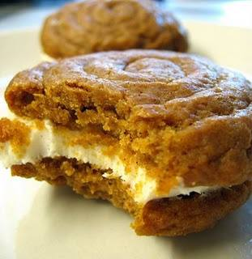
~Pumpkin Whoopie Pies with Cream Cheese Filling~
Makes 12-14
Ingredients
3 cups AP Flour
1 Tablespoon cinnamon
1 teaspoon baking soda
1 teaspoon baking powder
1 teaspoon ground ginger
½ teaspoon salt
½ teaspoon ground nutmeg
¼ teaspoon ground cloves
1 cup brown sugar
1 cup Splenda (use could white sugar if you like)
1 cup vegetable oil
1 - 15 oz. can of pumpkin
2 large eggs
1 teaspoon vanilla extract
Directions
Preheat oven to 350 degrees.
Beat together brown sugar, Splenda, oil and pumpkin. Add eggs one at time, mixing well after each addition, followed by the vanilla. In a separate bowl, shift together the dry ingredients. Slowly incorporate the dry ingredients into the wet until just combined.
Using a pastry bag with a round tip, or a big zip top plastic bag with one corner snipped, squeeze out concentric circles of batter, starting from the middle and working outward until the circles are about 2 inches in diameter. Bake for 11 minutes and cool on a rack.
Cream Cheese Filling
1 - 8 oz. package of cream cheese, softened
1 stick of unsalted butter, room temperature
1 - 16 oz. package of powdered sugar
about a capful of vanilla extract
a pinch of cinnamon (to taste)
Beat together cream cheese and butter. Add powdered sugar, vanilla and cinnamon. Frost flat side of half the pies and top with another piece.
Enjoy right away or chill overnight.
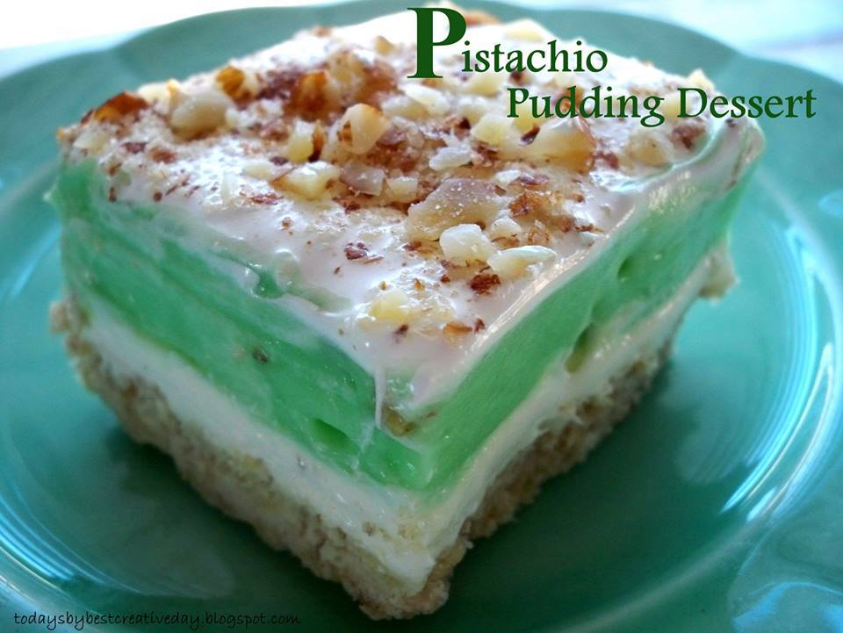
Pistachio Pudding Dessert
Pie crust:
1 stick butter
1 cup flour
1 cup chopped walnuts
Layer 1:
1 cup powdered sugar
1 (8oz) cream cheese
1 cup cool whip
Layer 2:
2 regular sized pkgs instant pistachio pudding mix
3 cups milk
Topping:
cool whip
chopped almonds
Mix butter, flour, nuts; press into 9x13 inch pan. Bake 350 for 20 min. Cool. Mix powdered sugar, cream cheese and cool whip; spread on cooled crust. Beat together pudding mix and milk until thick. Spread on cream cheese layer and top with a layer of cool whip and chopped nuts. Refrigerate.

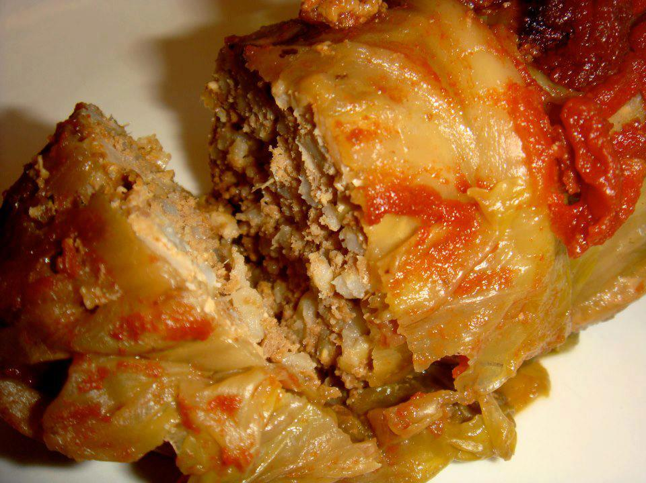
Oven Baked Cabbage Rolls
12 cabbage leaves
1 pound ground beef
3/4 cup cooked rice
1/2 cup finely chopped onion
2 cloves garlic, minced
1 egg
2 teaspoons salt
1 teaspoon pepper
1/2 cup milk
Sauce:
1 cans (8 ounces ) tomato sauce
1 can (14.5 ounces) diced tomatoes, undrained
3 tablespoons sugar
2 tablespoons vinegar
1/2 cup water
2 tablespoons cornstarch mixed with 1/4 cup cold water
Drop cabbage leaves into boiling salted water; cover and cook for 3 minutes. Drain well. Combine ground beef, rice, onion, egg, and salt, pepper, and milk. Mix well and divide into 12 portions.
Place a portion into the center of each cabbage leaf. Roll leaf around filling; fasten with toothpick. Place in a baking dish.
For sauce, combine tomato sauce, tomatoes, sugar, vinegar, and 1/2 cup of water and pour over cabbage rolls. Bake covered in a preheated 350 degree oven 40 to 45 minutes. Remove rolls and discard toothpicks. Place pan with juices over medium heat and stir cornstarch and water mixture into the sauce; bring to a boil and cook and whisk until thickened. Pour thickened sauce over cabbage rolls or serve on the side.

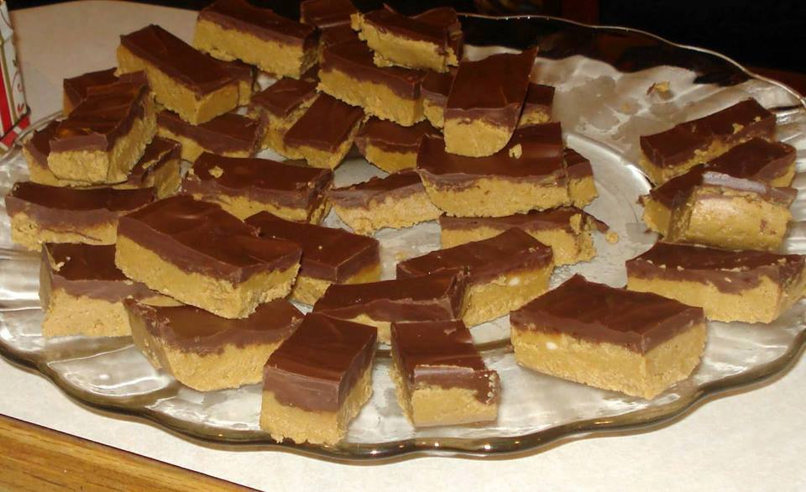
NO-BAKE PEANUT BUTTER BARS
1 cup salted butter (melted)
2 cups graham cracker crumbs
1/4 cup brown sugar
1 3/4 cup powdered sugar
1 cup peanut butter
1/2 tsp. vanilla
1 (11 ounce) bag milk chocolate chips
Combine all ingredients, except chocolate chips in a medium sized bowl. Stir until the mixture is smooth and creamy.
Pour peanut butter mixture into a 9x13 pan.
Melt chocolate chips in the microwave for 1-2 minutes. Stir chocolate and pour over the peanut butter mixture. Spread chocolate with a spatula.
Refrigerate bars for one hour. Cut while bars are still cool

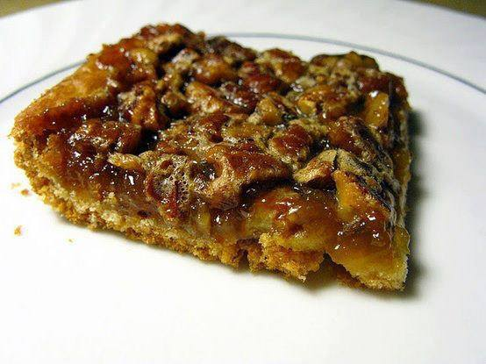
CRESCENT PECAN PIE SQUARES
Crust
1 can refrigerated crescent dinner rolls
Filling
1/2 cup chopped pecans
1/2 cup sugar
1/2 cup corn syrup
1 tablespoon butter or margarine, melted
1/2 teaspoon vanilla
1 egg, beaten
1.Heat oven to 350°F.
2.Unroll dough; separate dough into 2 long rectangles. Place in ungreased 13×9-inch pan; press over bottom and 1/2 inch up sides to form crust. Firmly press perforations to seal. Place in ungreased 13×9-inch pan; press over bottom and 1/2 inch up sides to form crust.
3.Bake 8 minutes. Meanwhile, in medium bowl, mix filling ingredients. Pour filling over partially baked crust.
4.Bake 18 to 22 minutes longer or until golden brown. Cool completely, about 1 hour. For bars, cut into 6 rows by 4 rows. Store at room temperature.

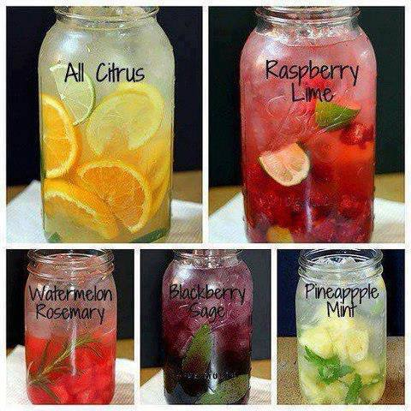
SPRING CLEANSE ~ YOUR BODY ~
1) The classical : lemon/cucumber: Mix in a pitcher: 10 cups of water + 1 cucumber and a lemon, thinly sliced + 1/4 cup fresh finely chopped basil leaf + 1/3 of finely chopped fresh mint leaves. Leave in the refrigerator overnight before serving.
2) The granite : Strawberry/Lime or Raspberry/Lime: Mix in a pitcher : 10 cups of water + 6 strawberries / 0r Raspberries and one thinly sliced lime + 12 finely chopped fresh mint leaves. Leave in the refrigerator overnight before serving.
3) The digestive : Fennel/citrus: First: infuse 1 to 3 grams of dried and crushed fennel in 150 ml of boiling water for 5-10 minutes. Allow to cool. Mix in a pitcher: 10 cups of water + lemon juice (put the leftover lemon in the mix) + a small thinly sliced orange + 12 fresh chopped mint leaves + the infusion of fennel seeds. Leave in refrigerator overnight before serving.
4) The antiOX : Blackberry/Sage: Note that a part from the berries, sage leafs is the herb that has the highest antioxidant content. Mix in a pitcher : 10 cups of water + 1 cup of blackberries that have been very slightly crushed + 3-4 sage leaves. Leave in refrigerator overnight before serving.
5) WATERmelon : watermelon/Rosemary: Mix in a pitcher : 10 cups of water + 1 cup of watermelon cut into cubes + 2 rosemary stems. Leave in refrigerator overnight before serving.
6) The exotic : Pineapple/Mint: Mix in a pitcher : 10 cups of water + 1 cup of pineapple cut into cubes + 12 fresh mint leaves finely chopped. Leave in the refrigerator overnight before serving.
7) The traditional : Apple/cinnamon: Mix in a pitcher : 10 cups of water + 1 cup of apple cut into cubes + 2 cinnamon sticks + 2 teaspoon of ground cinnamon. Leave in the refrigerator overnight before serving.
8.) The zingibir : Ginger/tea: In advance: heat 1 teaspoon of ginger in two cups of tea, let it cool down. Mix in a pitcher: 10 cups of water with two cups of the ginger tea + 4-5 pieces of fresh ginger cut into cubes. Leave in the refrigerator overnight before serving.

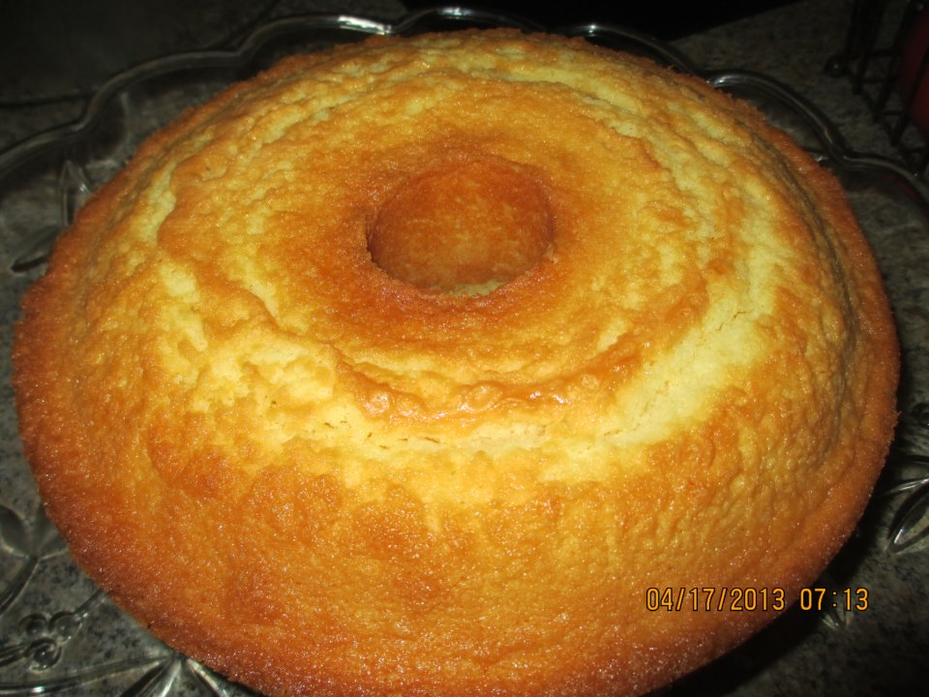
Cream Cheese Pound Cake..
.with any flavoring you want..
Ingredients:
3 stick of butter(softened)
1 8 oz cream cheese(softened)
3 cups of sugar
6 eggs
3 cups of plain flour(sifted)
1/4 teaspoon salt
1/4 teaspoon baking powder
1 teaspoon of any flavorings you have...I have 10 different
flavoring so I used all in this cake..but you can use
whatever you like ..I love mixing them up to get a different
taste with each
bite..
Mix butter and cream cheese..add sugar 1 cup at a time..mix..
add eggs 1 at a time mix well..add flour 1 cup at a time ...add salt and baking power..mix well and then add the flavorings of your choice...mix well...
Spray or grease your pound cake pan ..pour in batter
Bake at 300 for 1 hr and 30 mins...

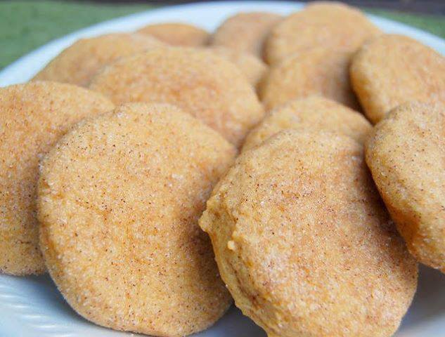
Pumpkin Snickerdoodles~
For the cookies:
3 3/4 cups flour
1 1/2 teaspoons baking powder
1/2 teaspoon salt
1/2 teaspoon ground cinnamon
1/4 teaspoon ground nutmeg
2 sticks unsalted butter, room temperature
1 cup sugar
1/2 cup dark brown sugar
1 cup pumpkin puree
1 large egg
2 teaspoons vanilla extract
For the coating:
1/2 cup sugar
1 teaspoon ground cinnamon
1/2 teaspoon ground ginger
Dash of allspice
In a medium bowl, combine flour, baking powder, salt, cinnamon, and nutmeg. Whisk together to blend. In a large bowl, beat together butter and sugars on medium speed until well combined. Next, still on medium speed, beat in pumpkin. Then, add the egg and vanilla extract. Lastly, add in the dry ingredients. Beat until combined, but do not over mix. Cover the dough, and refrigerate for one hour, until firm.
Preheat oven to 350 degrees.
Line baking sheets with parchment paper (or spray with nonstick spray). In a small bowl, mix together the sugar and spices for the sugar coating. Scoop dough (approximately 2 1/2 tablespoons) and roll into a ball. Roll the dough ball in the sugar mixture, and place on the lined baking sheet, leaving about 2 inches between each cookie. Take a drinking glass with a flat bottom and moisten with water. Dip the glass in the sugar mixture, and use it to flatten the dough balls. Re-sugar the glass as needed.
Bake the cookies for 10-12 minutes. Remove when the centers of the cookies have set. Let cool on the baking pan for approximately 5 minutes, and then transfer to wire cooling racks to cool completely.

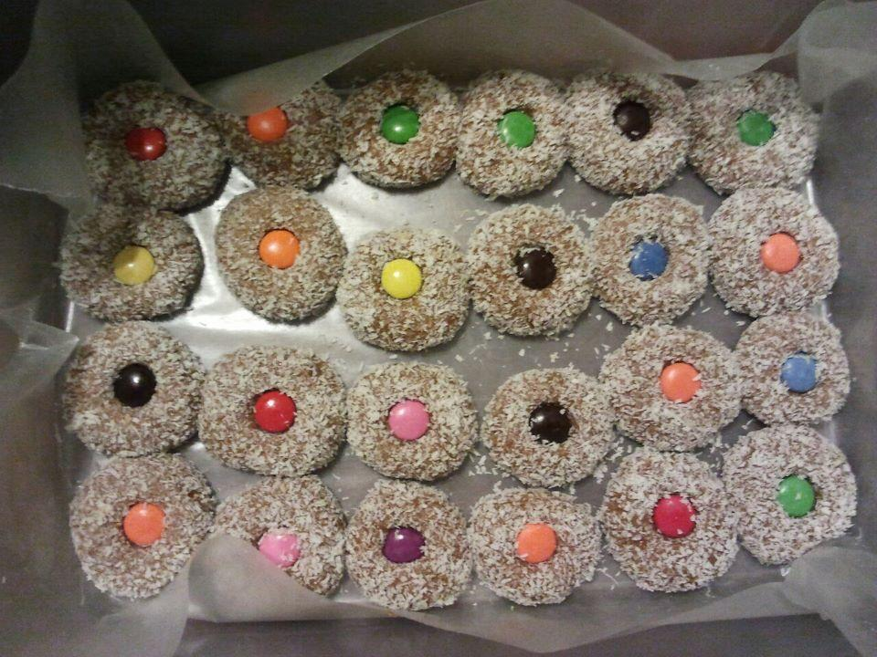
Smartie Cookies
1/2 bag small white marshmallows
1 can sweetened milk
1/2 cup butter
1 tsp vanilla
3 cups graham wafer crumbs
4 tsp coco
3/4 cup coconut
Melt marshmallows, sweet milk, butter, and vanilla in microwave for 2 mins (until marshmallows are dissolved when stirred) Stir mixture and add rest of ingredients. Cool for 1/2 hour and roll in coconut and put a smartie in center or each cookie.

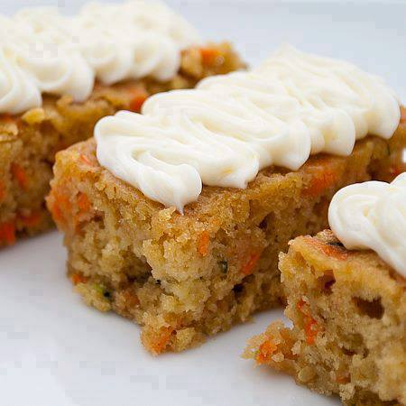
Carrot and Zucchini Bars w/ Lemon Cream Cheese Frosting

Ingredients:
•2 eggs, slightly beaten
•3/4 cup packed brown sugar
•1/2 cup canola oil
•1/4 cup honey
•1 tsp vanilla
•1 1/2 cups shredded carrot
•1 cup shredded zucchini
•1/2 cup chopped walnuts
•1 1/2 cups all-purpose flour
•1 tsp baking powder
•1/2 tsp ground ginger
•1/4 tsp baking soda
Lemon Cream Cheese Frosting
•1 (8 oz) pkg reduced fat cream cheese
•1 cup powdered sugar
•1 1/2 tsp lemon zest

1.Preheat oven to 375 . In a large bowl, whisk together the eggs, brown sugar, oil, honey, and vanilla. Don’t worry about clumps of the brown sugar, those will dissolve as it sits while you prepare the remaining ingredients. Then fold in the carrot, zucchini, and walnuts
2.In another bowl combine add the flour, baking powder, ginger, and baking soda. Whisk to blend together.
3.Add to flour mixture to the wet mixture. Stir just until combined. Spread batter into an ungreased 13x9x2-inch baking pan.
4.Bake about 25 minutes or until a toothpick inserted in center comes out clean. Cool completely in pan on a wire rack.
5.Once the cake is cooled prepare the frosting. In a medium mixing bowl, beat the frosting ingredients with an electric mixer on medium speed until fluffy. Spread or pipe the frosting over the cooled bars. Makes 36 bars.

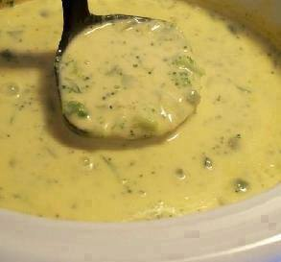
Broccoli Cheese Soup for the Crock Pot
1/2 cup green pepper, chopped
1/2 cup onion, chopped
2 tablespoons butter or 2 tablespoons margarine
1 (10 ounce) can cream of chicken soup
1 1/2 cups milk
1 lb Velveeta cheese, cubed
1 (10 ounce) package frozen chopped broccoli
Directions:
1 Sauté onion and green pepper in butter.
2 Combine all ingredients on low in crockpot for 3-4 hours. Do not add salt.

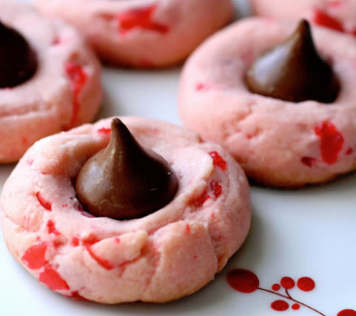
Chocolate Kiss Cherry Cookies
1 Cup Powdered Sugar
1 Cup Butter, Softened
2 teaspoons Maraschino Cherry Liquid
1/2 teaspoon Almond Extract
3 to 4 Drops Red Food Coloring
2 1/4 Cups Flour
1/2 teaspoon Salt
1/2 Cup Maraschino Cherries, Drained and Chopped
About 48 Milk Chocolate Candy Kisses, Unwrapped
1. Preheat oven to 350º
2.Combine Powdered Sugar, Butter, Cherry Liquid, Extract, and Food Coloring in a bowl. Mix well
3.Add Flour and Salt. Mix well
4.Stir in the Cherries
5.Shape Dough into 1" balls
6.Place 2" apart on ungreased sheets
7.Bake for 8 - 10 minutes or until you can see that the lower edge is a light golden brown
8.Quickly press a candy kiss into the top each cookie.

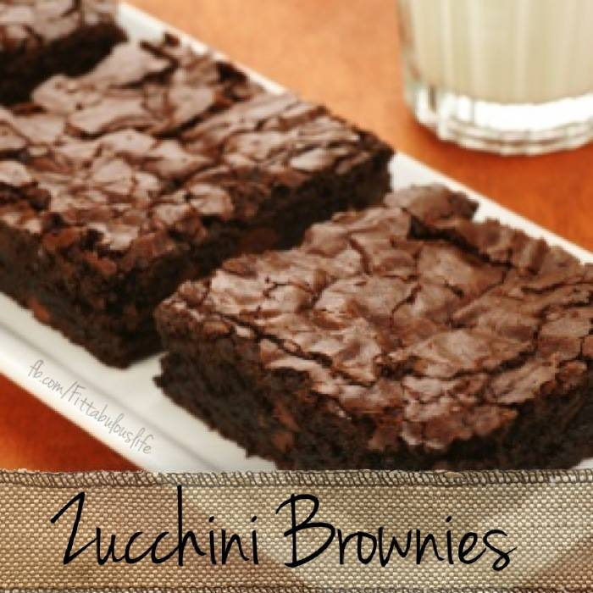
Zucchini Brownies
Brownies made with zucchini, bananas and applesauce, yielding a brownie with only 120 calories, 2 grams of fat, and a whole bunch of vitamins and minerals, and egg free. YESSSS!!!!
These are even a very moist low fat chocolate brownie alternative, for weight watchers, only 2 ww points per serving ( 24 servings). Its not going to be the same box brownie, but especially someone that only eats sweets occasionally like me, this healthier option is delish and guilt free!!
Ingredients
1/2 cup applesauce
2 small or medium bananas mashed
1 1/2 cup sugar
2 tsp. vanilla extract
1/2 cup cocoa powder
1 1/2 tsp. baking soda
1/2 tsp salt
2 cups finely shredded zucchini
2 cups all purpose flour
1/2 cup walnut pieces
Directions:
Preheat oven to 350 degrees F. Grease and flour an 9x13 inch baking pan. In a large bowl, mix together the applesauce, mashed bananas and sugar. Add vanilla and cocoa and mix together. Then add baking soda, salt, and zucchini and mix together. Add flour and walnuts and mix together. Spread evenly into a prepared pan. Bake for 25 minutes until brownies spring back when gently touched.

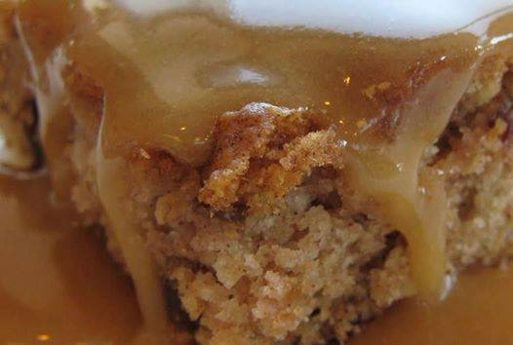
You're going to just DIE over this recipe!...
2 SIMPLE ingredients: 1- 21oz can of apple (or fruit of your choice) pie filling and 1 box of angel food cake mix.....that's it! NOTE: you MUST use the ONE-STEP (the kind that only requires water) cake mix for this to work....but DO NOT add the water!
Mix the 2 ingredients together (the dry packet of cake mix and the undrained can of fruit/filling) pour in a greased 9x13 pan or dish and bake for about 20 minutes at 350 (or according to baking directions on the box).
People....it can't get ANY easier than this! A dollop or 3 of ice cream finishes it off perfectly

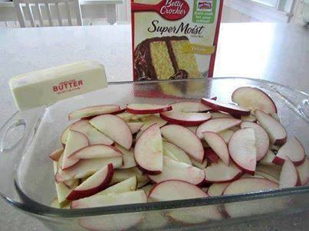
FRESH APPLE CAKE
Oh my gosh!!!! How easy is this??? Pretty soon apple harvests will begin and apples will be inexpensive and in abundance in our stores... Buy organic if you can!
About 5 to 7 granny smith apples (or whatever you prefer), peeled, cored & thinly sliced
1 (9 ounce) package yellow cake mix
2 tablespoons sugar
1 tablespoon ground cinnamon
1 stick real butter
Directions:
1. Preheat oven to 350°F.
2. Cut apple slices crosswise in half.
3. Place in pan; sprinkle with dry cake mix.
4. In small bowl, combine sugar & cinnamon; sprinkle over cake mix.
5. Drizzle with butter.
6. Bake 30 minutes or until topping is golden brown.
7. Serve warm with ice cream, if desired!
FRESH APPLE CAKE
Layer your apple slices (or other fruit) at the bottom of a pan that has been coated with non-stick spray.
Sprinkle on boxed cake mix.
Pour melted butter over the fruit and dry cake mix.
Bake at 180/350* for approximately 35-45 minutes -- it's done when it is nice and bubbly.

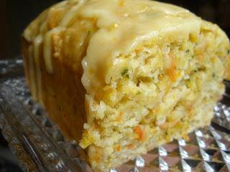
Orange Zucchini Bread
Ingredients:
Makes 2 loaves (freezes beautifully sans glaze)
3 cups flour
2 cups zucchini
1 teaspoon salt, scant
1 teaspoon baking powder
1/4 teaspoon baking soda
1 cup granulated sugar
1/2 cup applesauce, or egg substitute
1/3 cup vegetable oil
zest of one orange
1/2 teaspoon vanilla
1 tablespoon orange juice
1/3 cup walnuts or raisins
Glaze:
1/2 cup powdered sugar
2 tablespoon orange juice
1/4 teaspoon zest
Preparation:
1. Preheat the oven to 350. Grease two loaf pans.
2. Wash and dry the zucchini. Using a box grater grate 2 cups worth and set aside.
3. Sift the flour, salt, baking powder and baking soda. Mix well with a whisk and make a well in the center of the mixture.
4. Wash and zest the orange.
5. In another cup mix the egg substitute (or applesauce), orange zest, juice, vanilla, oil and sugar until combined. Add to the flour mixture, folding gently until combined.
6. Fold in the zucchini (and walnuts or raisins if you are using them) and split the batter between the two greased loaf pans.
7. Bake for 40 minutes or until golden and a tooth pick inserted in the center of the bread comes out clean.
8. Prepare the glaze: Mix the remaining orange juice and 1/2 cup of powdered sugar in a small bowl. Add the remaining zest and stir until smooth and combined.
8. Cool the bread for 10 minutes in the pans. Then, run the blade of knife around the loaf to gently separate it from the sides of the pan. Invert the loaves and the bread should slide out. Place on a wire rack with a large pan or plate below it to finish cooling.
9. While the bread is still hot spoon half of the glaze onto the top of each loaf. It will almost immediately drip down the sides of the loaf. Cool completely before serving.

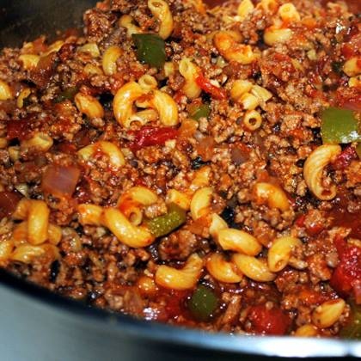
~~Italian Style Goulash Recipe~~
Ingredients
grated parmesan cheese, to taste
2 garlic cloves, minced ( estimate)
2 tablespoons italian seasoning ( estimate)
salt and pepper
2 cups cooked pasta of your choice
1 (6 ounce) cans mushrooms, drained
1 (15 ounce) cans kidney beans
1 (28 ounce) cans tomato sauce
1 (28 ounce) cans diced tomatoes
2 large onions
2 green peppers, cut up
1 1/2 lbs ground beef or 1 1/2 lbs ground turkey
1/4 cup bacon
Directions
Fry bacon and cut into bite-size pieces. Set aside.
Brown ground beef/turkey, onions, and green peppers in a large skillet.
Stir in tomatoes, tomato sauce, kidney beans, mushrooms, Italian Seasoning, and garlic.
Cover and cook at medium heat for 15 minutes.
Stir in bacon and cooked macaroni.
Place in lightly-greased 9x13 casserole dish.
Sprinkle cheese on top and bake at 350 degrees for 1 hour.

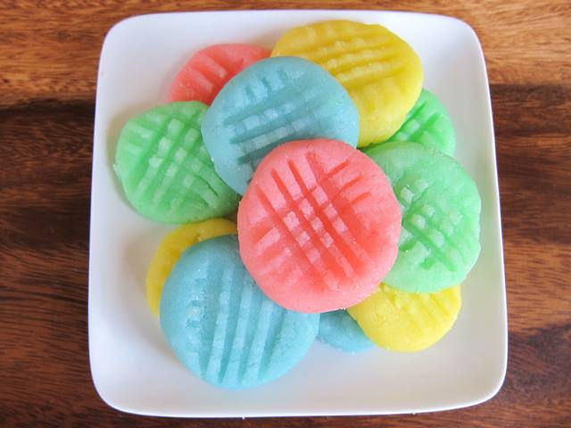
Cream Cheese Candies-No Bake
You can do these in any colors and flavors, adjust them for holidays, birthdays or weddings.
kosher recipe
1/4 cup unsalted butter
1 package (8 oz.) cream cheese
4-5 cups powdered sugar
1 tsp flavoring - peppermint, vanilla butter, lemon, banana, etc.
Food coloring
Melt butter in saucepan over med heat. Add cream cheese, stir until softened and partly melted into butter.
Turn off heat. Add 4 cups powdered sugar t bgffb fo pan and stir to form soft dough.
Divide dough into 4 portions (or however many colors and flavors you want to make) Add 1/4 tsp flavoring to each portion of dough, stir well.
Color dough by adding few drops of food coloring to each portion of dough. Shape the candies into rounds of about 1/2 tsp each. Score with fork.
Dry on wax or parchment paper for a few hours until set. Store in sealed container in refrigerator.

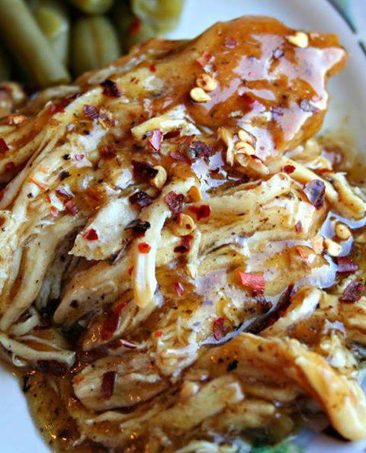
Crock Pot Sweet Garlic Chicken
4-6 chicken breasts
1 cup packed brown sugar
2/3 cup vinegar (I used apple cider vinegar)
1/4 cup lemon-lime soda (diet or regular)
2-3 Tablespoons minced garlic
2 Tablespoons soy sauce
1 teaspoon fresh ground pepper
2 Tablespoons corn starch
2 Tablespoons water
Red pepper flakes (optional)
Spray slow cooker with non-stick cooking spray. Place chicken (frozen, thawed or fresh) inside slow cooker. Mix together brown sugar, vinegar, soda, garlic, soy sauce, and pepper together. Pour over chicken. Cook on low for 6-8 hours or high for 4 hours.
Take chicken pieces out of slow cooker (basically may fall apart) and pour remaining sauce into saucepan. Place saucepan over high heat. Mix together corn starch and water, pour into saucepan, and mix well. Let sauce come to a boil and boil for 2-3 minutes, or until it starts to thicken and turns into a glaze. Remove from heat and let sit for a minute or two (it will continue to thicken as it cools down).
Sprinkle red pepper flakes on top if desired. This can be served over rice or noodles.

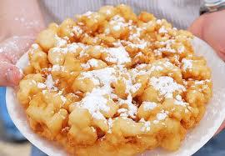
State Fair Funnel Cakes
3 largeEGGS
1/4 cupSugar
2 cupsmilk
3 2/3 cupsFlour
1/2 teaspoonSalt
2 teaspoonBaking Powder
Vegetable oil
Preparation
Beat eggs and sugar together and then add the milk slowly--beat. Add the dry ingredients and beat until smooth and creamy.
Pour batter into a funnel and at the same time, use your finger to plug the hole. In a large cast iron pot, add 2 inches of oil to the bottom.
When the oil becomes hot, move your hand over the pot and slowly release your finger so the batter can start cooking.
Move the funnel around to make designs.
Brown on both sides--then immediately remove and drain extremely well.
Top with cinnamon sugar, or powdered sugar as a topping.

Bacon Bombs:
1 can (8ct.) Pillsbury Grands Flaky Layers Biscuits
Cubed Mozzarella Cheese (1-1″ cube per Bomb)
2 lbs. of Bacon (1 slice per Bomb)
Sticks
Oil for frying (I used Canola)
Directions:
Cube up the Cheese, and cut each Biscuit into fourths. Place one piece of Cheese inside a Biscuit quarter, and roll it up in there, nice and tight…
Wrap each rolled Bomb in a slice of Bacon, and secure it with a skewer or toothpick…
In a med/large pot, heat up approx. 2″ of Oil (to 350 degrees) and fry them up in small batches. Maybe one or two at a time, the oil will expand so stay close… Drain them on some Paper Towel, but serve them up good and warm. YUM!!

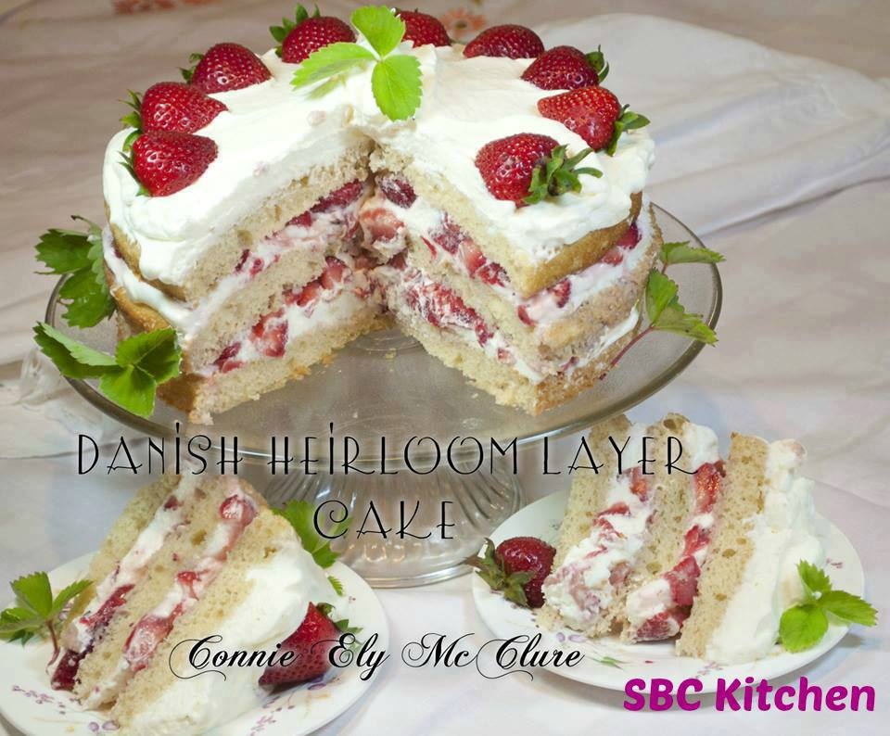
Connie's Danish Heirloom Layer Cake
Ingredients:
1/2 cup vanilla yogurt
1/2 cup sour cream
pinch salt
1 egg
1/2 tsp. baking soda
1 tsp. baking powder
1 + 1/2 cups flour
1 tsp. vanilla
1 pint whipping cream - whipped and sweetened with 1 Tbsp. icing sugar
1 - 2 pounds sliced slightly sweetened strawberries - or fruit of choice
Directions:
In a medium bowl, mix together with a whisk or wooden spoon, yogurt, sour cream, egg, salt, baking soda, baking powder. Add flour and vanilla.
Grease or spray 3 - 9" layer pans and divide batter evenly between pans. (the batter will seem skimpy....but spread as evenly as you can with a spatula in each pan - layers will rise on baking).
Bake at 350 oven (325 if using Convection oven 325 oven) Bake for only 10 - 12 minutes....till Very Light Brown. Cool on racks...and remove from pans with a plastic spatula onto racks to finish cooling as soon as you can handle the cakes.
IMPORTANT: Do NOT over bake!! If not using immediately - put wax paper between layers, cover with plastic and refrigerate or freeze till ready to assemble cake.
Layer cake layers: 1/3 whipped cream and 1/2 sweetened sliced strawberries, or fruit of choice - then 1/3 whipped cream and 1/2 berries. Last layer - just whipped cream. Decorate with berries.
This cake tastes even better the next day and the day after that....if there is any left!! The Trick is Not to Over bake the layers...or it will be dry and not nice and moist.
This will soon become Your Favorite Family Cake too!

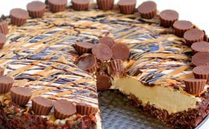
Frozen Peanut Butter Cheesecake
Ingredients
6 tablespoons butter
1 1/2 cups semi-sweet chocolate chips
2 1/2 cups crispy rice cereal
1 (8 ounce) package cream cheese, softened
1 cup sweetened condensed milk
3/4 cup creamy peanut butter
1 teaspoon vanilla
2 tablespoons lemon juice
1 cup frozen whipped topping, thawed
2 tablespoons hot fudge sauce
2 tablespoons creamy peanut butter
Directions
1. In a medium microwave safe bowl, melt butter and chocolate chips in the microwave for about a minute or until melted. Stir together until combined. Add crispy rice cereal and stir well to coat.
2. Press into the bottom and up the sides of a 9-inch springform pan. You could use a pie pan but I've found that a springform pan is much easier when it comes to removing slices. Place in the freezer to chill while you make the filling (about 10 minutes).
3. In a large bowl beat cream cheese until fluffy. Add the sweetened condensed milk and peanut butter and mix until thoroughly combined.
4. Add vanilla and lemon juice and mix until combined.
5. Gently fold in the whipped topping. Pour filling into the prepared crust.
6. Heat fudge and peanut butter in two small separate bowls for 20-30 seconds or until warm. Drizzle over filling.
7. Freeze for 4-6 hours or until pie is firm. Remove the cheesecake from the freezer about 10 minutes before serving to make cutting easier. Garnish with peanut butter and chocolate candy bars.

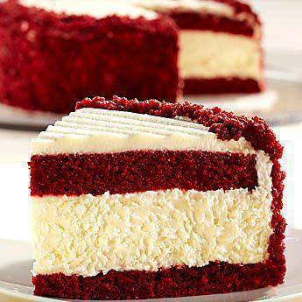
Red Velvet Cheesecake
Two (8-ounce) packages cream cheese, at room temperature
2/3 cup granulated white sugar
pinch of salt
2 large eggs
1/3 cup sour cream
1/3 cup heavy whipping cream
1 teaspoon vanilla extract
RED VELVET CAKE:
2 1/2 cups all purpose flour
1 1/2 cups granulated white sugar
3 tablespoons unsweetened cocoa powder
1 1/2 teaspoons baking soda
1 teaspoon salt
2 large eggs, at room temperature
1 1/2 cups vegetable oil
1 cup buttermilk
1/4 cup (two 1-ounce bottles) red food coloring
2 teaspoons vanilla extract
2 teaspoons white vinegar
CREAM CHEESE FROSTING:
2 1/2 cups powdered sugar, sifted lightly to remove any lumps
Two (8-ounce) packages cream cheese, at room temperature
1/2 cup unsalted butter, at room temperature
1 tablespoon vanilla extract
Prepare the cheesecake layer: Preheat oven to 325 degrees. Place a large roasting pan on the lower third rack of the oven. Place a kettle of water on the stove to boil. Spray a 9-inch spring form pan with nonstick spray and line the bottom with a round of parchment paper. Wrap a double layer of foil around the bottom and up the sides of the pan (you want to seal it so the water from the water bath doesn't seep into the pan).
In a large bowl, use an electric mixer to mix the cream cheese- blend until it is nice and smooth and creamy. Mix in sugar and salt and blend for 2 minutes, scraping down sides of the bowl as needed. Add eggs, one at a time, blending after each addition. Finally, mix in sour cream, whipping cream and vanilla. Mix until smooth. Pour the batter into the prepared pan. Set the pan into the roasting pan in the pre-heated oven. Carefully pour the hot water from your kettle into the roasting pan (it will fill the pan surrounding the cheesecake).
Pour enough water so that there is about an inch of water coming up the foil along the sides of the cheesecake pan. Bake the cheesecake for 45 minutes. It should be set to the touch and not jiggle. Remove the cheesecake from the roasting pan and let it cool on a wire rack for at least an hour. When it has cooled, place the pan into the freezer and let the cheesecake freeze completely. This can be done in several hours- or overnight.
Continued
Continued
Prepare the cake layers: Preheat oven to 350 degrees. Grease and flour two 9-inch round metal baking pans (or spray with nonstick baking spray with flour). In a large bowl, whisk together flour, sugar, cocoa powder, baking soda and salt. Add eggs, oil, buttermilk, food coloring, vanilla and vinegar to the flour mixture. Using an electric mixer on medium-low speed, beat for 1 minute, until blended. Scrape sides and bottom of bowl with a rubber spatula. Beat on high speed for 2 minutes. Spread the batter evenly into the prepared pans, dividing equally. Bake 30 to 35 minutes or until a toothpick inserted in the center comes out with a few moist crumbs attached. Let cool in pans on a wire rack for 10 minutes. Run a knife around the edge of the pans, then invert cakes onto a rack to cool completely.
Prepare the frosting: In a large bowl, using an electric mixer on medium-high speed, beat powdered sugar, cream cheese, butter and vanilla until it is smooth and creamy (do not over beat).
Assemble the cake: Place one cake layer into the center of a cake plate or platter. Remove the cheesecake from the freezer, take off the sides of the pan, and slide a knife under the parchment to remove the cheesecake from the pan. Peel off the parchment. Measure your cheesecake layer against the cake layers. If the cheesecake layer turns out to be a slightly larger round than your cake, move it to a cutting board and gently shave off some of the exterior of the cheesecake to get it to the same size as your cake layers. Place the cheesecake layer on top of the first cake layer. Place the 2nd cake layer on top of the cheesecake.
Frost the cake: Apply a crumb coat layer to the cake- use a long, thin spatula to cover the cake completely with a thin and even layer of frosting. Be sure to wipe off your spatula each time you are about to dip it back into the bowl to get more frosting (this way you won't be transferring any red crumbs into the bowl of frosting). Don't worry at this point about the crumbs being visible in the frosting on the cake. When your cake has a thin layer of frosting all over it, place it into the refrigerator for 30 minutes to “set” the frosting.
Once the first layer of frosting is set, apply the 2nd layer. Start by adding a large scoop of frosting onto the top of the cake. Use a long, thin spatula to spread the frosting evenly across the top and then spread it down the sides of the cake too. Because you applied a crumb-coat layer, you shouldn't have any red crumbs floating around in the final frosting layer. Decorate, as desired. I recommend white chocolate shavings

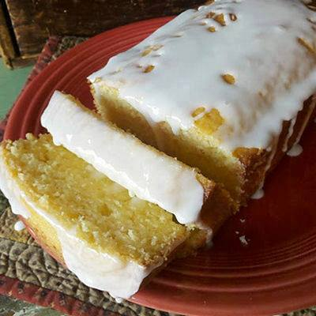
Starbucks Lemon loaf.
1 1/2 cup(s) FLOUR
1/2 teaspoon(s) BAKING SODA
1/2 teaspoon(s) BAKING POWDER
1/2 teaspoon(s) SALT
3 EGGS
1 cup(s) SUGAR
2 tablespoon(s) BUTTER; Softened.
1 teaspoon(s) VANILLA
1 teaspoon(s) LEMON EXTRACT
1/3 cup(s) LEMON JUICE
1/2 cup(s) OIL
LEMON ICING
1 cup(s) POWDERED SUGAR; Plus 1 Tablespoon.
2 tablespoon(s) WHOLE MILK; I Used 2%.
1/2 teaspoon(s) LEMON EXTRACT
Instructions
Combine flour, baking soda, baking powder and salt in a bowl.
Use a mixer to blend together the eggs, sugar, butter, vanilla, lemon extract and lemon juice in a medium bowl.
Pour wet ingredient into the dry ingredients and blend until smooth.
Add oil and mix well.
Pour batter into a well greased 9x5-inch loaf pan.
Bake at 350 degrees for 45 minutes or until a toothpick stuck into center of the cake comes out clean.
Make the lemon icing by combining all the icing ingredients in a small bowl with an electric mixer on low speed.
When the loaf is cool, remove it from pan and frost the top with the icing.
Let the icing set up before slicing.

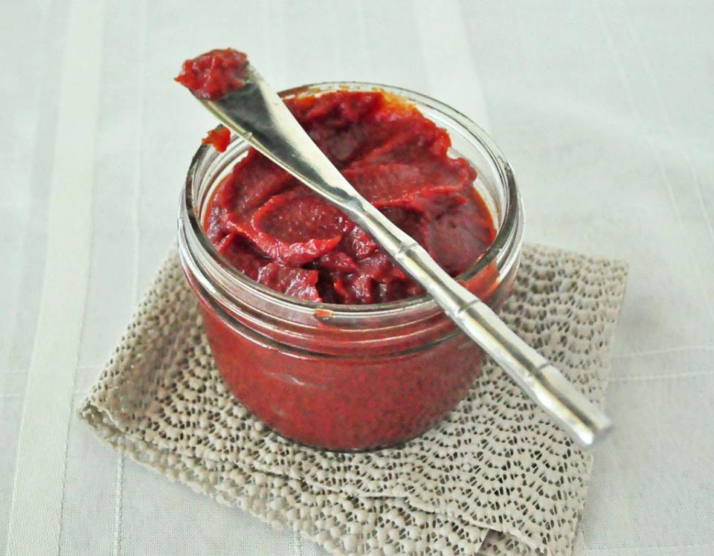
Homemade Ketchup
You probably had seen this coming. Lately, I have been doing a lot of condiments. First the BBQ Sauce, then the Dairy Free Ranch and now ketchup.
If you have toddlers like me, you know that kids just eat gobs of ketchup if they are not monitored. If my daughter had her way, she would eat it by itself. This was so easy to make and contains just a small amount of sweetener. Most commercial brands contain high fructose corn syrup. The few store bought brand that I have tried without high fructose corn syrup left a lot to be desired. This recipe makes about 1 cup and should keep in the fridge a few weeks. I store mine in a glass jar.
Homemade Ketchup
1 6 oz BPA free can or 1/3 cup tomato paste
1 T raw honey
1/4 cup white wine vinegar
1/2 tsp garlic powder
1/2 tsp onion powder
salt to taste
In a large sauce pan, heat all the ingredients together on med until everything is well combined.
Take a test taste. If you like a sweeter ketchup, add a tad more honey.
That’s it.

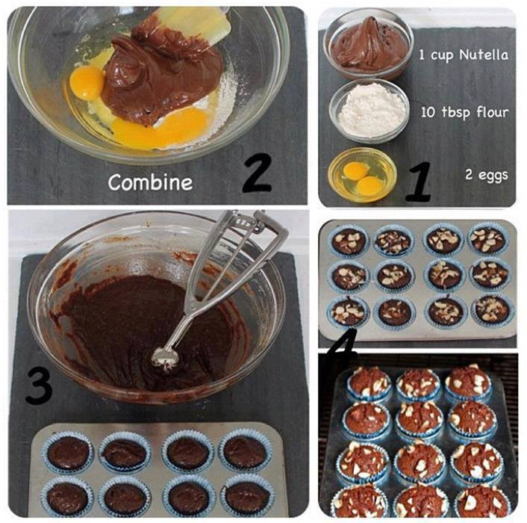
Nutella Brownie
I am about to change your life. I am about to make you the happiest person on the planet. I am about to show you how to make brownies with only three ingredients. And I am going to exploit the inherent fantastical properties of Nutella in doing so.
See, Nutella already has fat, milk, and chocolate in it. Since those are the things you would normally be adding to traditional brownies separately, why not use a product that already has these things - and hazelnuts! See, you knew Nutella was amazing. But maybe you didn't realize its full potential. Until today - the day you met three-ingredient Nutella brownies.
Go. Make these. Now.
Ingredients:
1 cup (280g) Nutella
2 eggs
10 tbsp (62g) flour
Directions:
Put it in a bowl. Mash it up. Pour into a pan or muffin tin. Top with hazelnuts if you're feeling extra fancy. Bake at 350F (180C) for around 30 minutes (less time for cupcake form, more time if the centers aren't baked through).
That's it. You're done. Eat them. Revel. Be amazed.

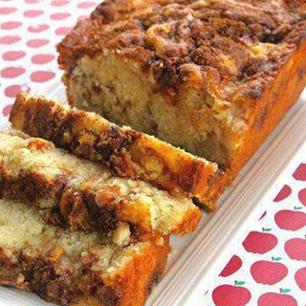
Apple Cinnamon Loaf
1/3 cup brown sugar (not packed)
1 teaspoon ground cinnamon
2/3 cup white sugar
1/2 cup butter, softened
2 eggs
1 1/2 teaspoons vanilla extract
1 1/2 cups all-purpose flour
1 3/4 teaspoons baking powder
1/2 cup milk
1 apple, peeled and chopped
Preheat oven to 350 degrees. Grease and flour a 9 x 5-inch loaf pan. Mix brown sugar and cinnamon together in a bowl and set aside. Beat white sugar and butter together in a bowl using an electric mixer until smooth and creamy. Beat in eggs, 1 at a time, until incorporated; add vanilla extract.
Combine flour and baking powder together in another bowl; stir into creamed butter mixture. Mix milk into batter until smooth. Pour half the batter into the prepared loaf pan. Next add half the apples and half the brown sugar cinnamon mixture. Lightly pat apple mixture into batter.
Pour the remaining batter over apple layer; top with remaining apples and add more brown sugar/cinnamon mixture. Lightly pat apples into batter; swirl brown sugar mixture through apples using a finger or spoon.
Bake in the preheated oven until a toothpick inserted in the center of the loaf comes out clean, 30 to 40 minutes

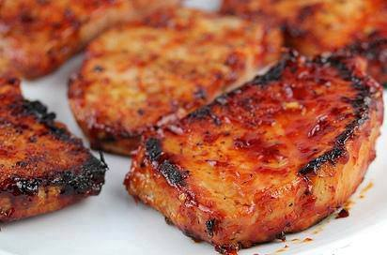.
Honey Garlic Pork Chops Recipe
Ingredients:
1 cup ketchup
1/3 cup honey
¼ cup soy sauce
2 garlic cloves (minced)
1 1/2lbs boneless pork chops (6 4 oz portions)
salt and pepper
Cooking Instructions:
Step 1: In a medium bowl stir together ketchup, honey, soy sauce and garlic. Set aside.
Step 2: Lightly season the pork chops on both sides with salt and pepper. Brush each chop with the sauce to coat.
Step 3: Grease the grill grates of an outdoor grill and heat the grill to medium-high heat. Place pork chops onto the grill, and cook (while basting with the sauce often) for about 5 minutes on each side or until the meat is cooked through (the internal temperature has reached 145 degrees).
(Makes 6 Servings

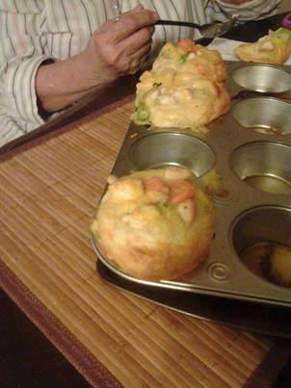
CHICKEN POT PIE
with just 4 ingredients? It couldn't get any easier!
Grands!® Chicken Pot Pie Puffs
2 cups Green Giant® frozen mixed vegetables, thawed
1 cup diced cooked chicken
1 can (10 3/4 oz) condensed cream of chicken soup
1 can (16.3 oz) Pillsbury® Grands!® Flaky Layers refrigerated biscuits
Heat oven to 375°F. In medium bowl, combine vegetables, chicken and soup; mix well.
Press each biscuit into 5 1/2-inch round. Place 1 round in each of 8 greased regular-size muffin cups. Firmly press in bottom and up side, forming 3/4-inch rim. Spoon a generous 1/3 cup chicken mixture into each.Bake at 375°F 20 to 22 minutes or until biscuits are golden brown. Cool 1 minute; remove from pan.
Tips
Substitute 2 cups of any frozen (thawed) vegetables you have on hand, such as broccoli, corn, peas or green beans, for the mixed vegetables.
If your family loves cheese, sprinkle some shredded Cheddar cheese over each puff about 5 minutes before the end of the baking time.

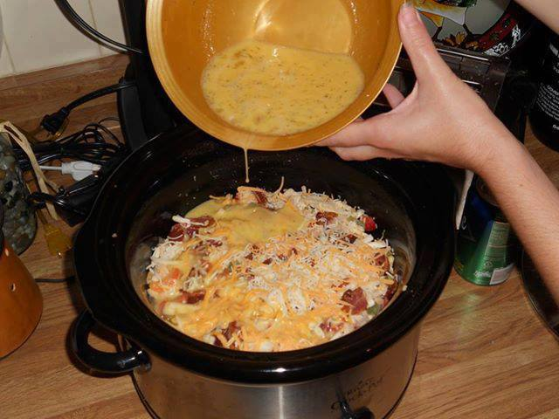
Breakfast casserole in the crock pot

Ingredients:
1 bag 26 oz. frozen hash browns
12 eggs
1 cup milk
1 tablespoon ground mustard
1 16 oz. roll sausage
maple, sage or regular sausage.
Salt and pepper
16 oz. bag shredded cheddar cheese
Directions:
1. Spray crock pot and evenly spread hash browns at the bottom.
2. Crack 12 eggs in a large bowl.
3. Mix well (and slowly) using a whisk.
4. Add the milk.
5. Go ahead and sprinkle in the ground mustard. This might sound like a weird ingredient, but I've come to love (and use) this in most of my recipes.
6. Add plenty of salt....
...and lots of fresh pepper. Mix well and set aside.
7. Cook the sausage on high heat, drain and set aside.
8. Add sausage on top of hash browns.
9. Is this enough cheese? Maybe? Probably. Throw the whole big bag in there.
10. Mix it up well. Or good, depending on where you're from.
11. Pour the egg mixture over everything in the crock pot. Using a wood spoon, even everything out so it's spread evenly.
12. Turn the crock pot on low for 6-8 hours.
Some fun variations of this recipe. Before cooking (during prep) you can add:
chunks of sourdough bread, diced chiles, salsa, diced green onions

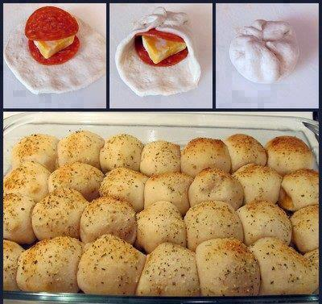
PIZZA BALLS
Ingredients:
3 cans Pillsbury Buttermilk Biscuits (10 ct)
60 pepperoni slices (2 per biscuit)
Block of cheese (Colby/Monterey Jack or Chedder)
1 beaten egg
Parmesan Cheese
Italian Seasoning
Garlic Powder
1 jar pizza sauce
Directions:
Slice cheese into approx. 28 squares. Flatten each biscuit and stack pepperoni and cheese on top (Like in the picture) Gather edges of biscuit and secure on top of the roll. Line rolls in greased 9x13 pan Brush with beaten egg. Sprinkle with parmesan cheese, Italian seasoning and garlic powder. Bake at 425 degrees F. for 18 to 20 mins. Serve with warm pizza sauce for dipping. ENJOY!!

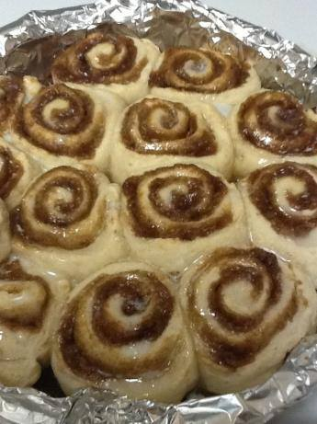
Quick Cinnamon Rolls - No Yeast

Ingredients:
Dough
2 cups flour
2 tablespoons sugar
4 teaspoons baking powder
1 teaspoon salt
3 tablespoons butter
3/4 cup milk
Filling
4 tablespoons butter
1 cup brown sugar or 1 cup white sugar
3 teaspoons cinnamon
Glaze
1/2 cup powdered sugar
1/4 cup milk
Directions:
1. For the filling, in a small bowl combine softened butter, brown sugar and cinnamon to form a crumbly mixture.
2. Sprinkle 1/2 of the mixture over the bottom of a 9x9 pan.
3. In a large bowl mix together flour, sugar, baking powder, and salt.
4. Cut in softened butter (sometimes your hands are the best tools).
5. Stir in milk to form a soft dough.
6. Roll out dough on a lightly floured into a rectangle about 1/4 inch thick.
7. Spread the remaining filling on the rolled out dough.
8. Roll up the rectangle, with a sharp knife slice into 18 small rolls (12 if you want them a little bigger).
9. Bake for 20-25 min at 400°F.
10. For glaze, combine powdered sugar and milk in a small bowl and stir until smooth.
11. Once rolls are finished, drizzle on glaze and serve warm.

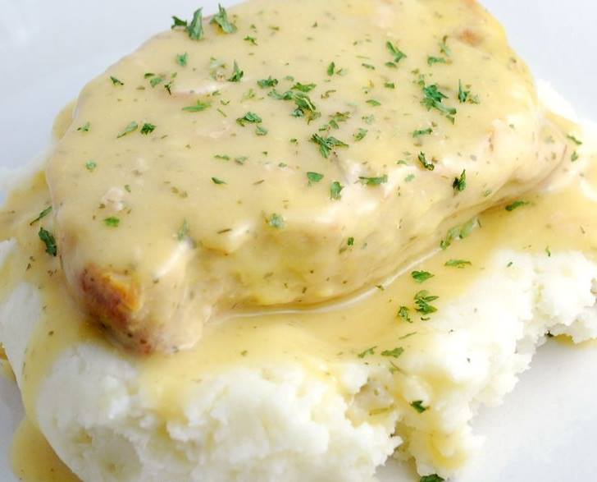
Ranch Crock Pot Pork Chops
4 pork chops, about 1/2" thick
a little oil for browning
1 Tbsp homemade ranch dressing mix (or you can use a Tbsp. from a store bought packet)
1 10-oz can cream of chicken soup, undiluted
Mashed Potatoes– I used my Garlic Mashed Potatoes
Quickly brown the pork chops on both sides over medium high heat in a little bit of oil. Don't completely cook them, just give them a quick sear. Place them in your crock pot and sprinkle with the ranch dressing mix. Pour the soup over the top. Cook on LOW heat for 5-6 hours, or on HIGH heat for 3-4 hours. Serve with hot mashed potatoes

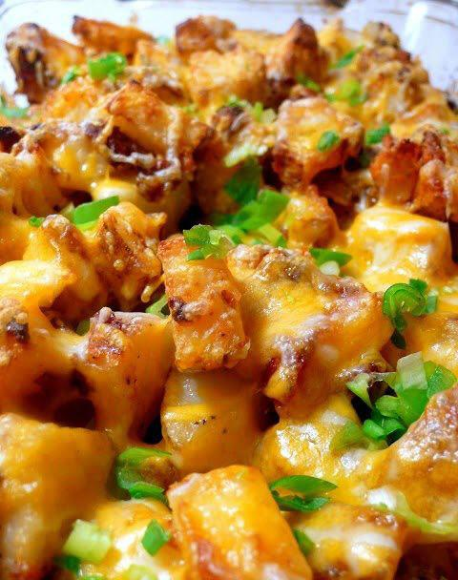
Roasted Ranch Potatoes
2 pounds potatoes (unpeeled, washed and cut into chunks)
1/2 cup ranch dressing (bottled, not packet)
1/2 cup shredded cheddar cheese, plus 1/4 cup more for topping
1/4 cup crumbled, cooked bacon or real bacon pieces from jar
1 tablespoon dried dill weed
3 scallions, washed and chopped
Salt
Pepper
Sour Cream (optional)
Non-stick cooking spray
Directions:
Preheat oven to 350 degrees.
Add (in a large bowl) the ranch dressing, dill, cheese and bacon. Add in the potatoes. Sprinkle in a generous pinch of salt and pepper. Toss to coat potatoes.
Spoon into a greased 9 x 13 baking dish. Cover with foil.
Bake for 60 minutes. Stir gently halfway through to get the bottom potatoes rotated so they don't become burnt and to ensure that the middle and top potatoes get a chance to brown.
Remove foil. Raise oven temperature to 400 degrees. Gently stir again, as necessary.
Bake for an additional 15 minutes, then sprinkle with additional cheese. Bake a few more minutes or until everything is gooey, browned and bubbly on top.
Serve with scallions sprinkled on top for garnish.
Great with a dollop of sour cream.

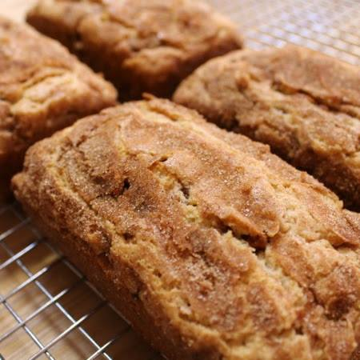
SNICKERDOODLE BREAD
Ingredients

2½ cups flour
2 tsp. baking powder
½ tsp. salt
2 tsp. cinnamon
1 cup butter softened
2 cups sugar
3 eggs
1 tsp. vanilla
¾ cup sour cream
1 pkg. Hershey's cinnamon chips
3 TB sugar
3 tsp. cinnamon

Directions
Cream butter, sugar, salt and cinnamon until fluffy. Add eggs and mix well.
Add vanilla and sour cream and mix well.
Mix flour and baking powder in a separate bowl. Add to wet ingredients and mix until all combined.
Add cinnamon chips and stir into batter. Set aside.
Spoon batter into 4 mini loaf pans until about 2/3 full.
Mix 3 T. sugar and 3 t. cinnamon in a bowl and sprinkle over the batter in each loaf pan.
Bake at 350 for 35-38 minutes. Let cool before removing from pan

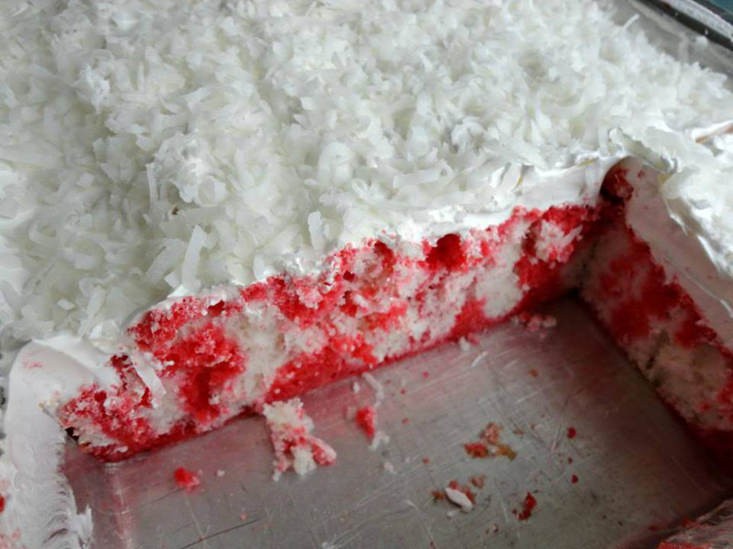
Raspberry Zinger Poke Cake
1 white or yellow cake mix (also water, vegetable oil and eggs/eggs whites as instructed on box)
1 box (3 oz.) raspberry-flavored gelatin
1 c. boiling water
1/2 c. cold water
1 container (8 oz.) Cool Whip, thawed
¾ cup shredded sweetened coconut
Bake cake according to package directions and cool completely. Pierce cooled cake all over with a fork. In a small bowl, stir gelatin and boiling water until sugar is dissolved. Stir in cold water. Pour over cake, cover, and refrigerate 2 or more hours (overnight is fine). Frost with whipped cream and sprinkle coconut over the top. Keep refrigerated until ready to serve. Serve cold and refrigerate any leftovers.

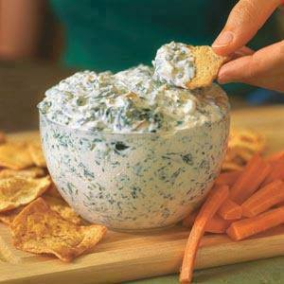
Secretly Healthy Spinach Dip!
Just a general trick, substituting cottage cheese for sour cream reduces that fat and adds a ton of protein to a meal. Just be sure to first blend the cottage cheese and no one will be able to tell the difference.
Ingredients needed:
1 10 oz container of frozen chopped spinach – defrost and squeeze out all the juice
1-2 5 oz cans of sliced water chestnuts – dice into small pieces
1 8 oz container of 1% cottage cheese – blend with a handheld blender or in a traditional blender until smooth and creamy
1 packet ranch dressing
After completing the above tasks, mix well, eat, and enjoy!
No baking or cooking needed.

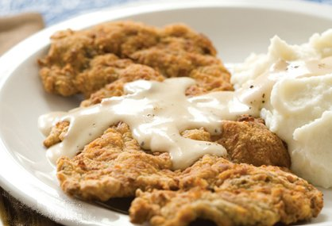
Chicken Fried Steak
This is my family Recipe, that I learned from my Brother Tim. The steaks will be more rounded, and won’t fit on a standard plate.. so plan 2 plates for each person, one for the steak.. and one for the potatoes and vegetables… LOL.. My family likes it with BBQ sauce too.. This is my Grandson’s “Chris” absolute favorite.

4 Beef Cube Steaks
2 Cups Flour
2 Cups Buttermilk
8 Eggs
Japanese Bread Crumbs, or I use Crushed Cracker Crumbs
Pepper to Taste
Oil For Frying

Directions
You will need a separate dish for each.. the Flour, the Buttermilk, the Eggs, and the Cracker Crumbs. I use Pie Plates for the first 3.. and a cookie sheet with edges for the cracker crumbs… Set up your dishes like this: First.. dish.. in the line, is the Buttermilk, then the flour, then the whipped Eggs, then the cracker crumbs.

Take a Beef Cube steak, and Dip into the Buttermilk, both sides.. drown it. Then carefully lift it out, place it in the flour and pat the flour into the beef cube steak.. this helps hold it all together. As you pat it.. you will see it grows larger just a little bit… don’t beat it.. just press lightly, covering both sides of the cube steak with flour.. Then lift it carefully out of the flour, and dip it into the whipped eggs.. on both sides… Then the fun part begins.. You should have LOTS and LOTS of crushed finely cracker crumbs.. Remember these must be crushed very fine.. I use a rolling pin to crush them…. Your Cookie sheet should be full of cracker crumbs. Place the egged cube steak into the cracker crumbs.. and cover with more cracker crumbs onto the top.. Now.. Press the cracker crumbs into the cube steak.. starting in the center and work your way out pressing to the edges.. DO NOT SLIDE YOUR HANDS ONTO THE STEAK.. JUST PRESS RELEASE.. PRESS RELEASE.. PRESS RELEASE.. Turn your steak over.. and do it again.. as you do this.. the steak is going to get bigger and bigger and bigger.. The more crumbs pressed into the meat.. the more Tender your Chicken fried steak is going to be.. The bigger it is.. the more tender… It will be so tender, you won’t need a steak knife to cut it… Now that it is super super large.. Bigger than a plate almost.. or larger.. Put it on another cookie sheet covered with wax paper, and put a piece of wax paper over the top.. and do your next steak.. stacking your 4 steaks ontop of each other.. When finished you are ready to fry them in a super large frying pan.
Make sure your oil in the frying pan is about a ½ inch deep.. and HOT !!! Put the steak in.. be careful not to splatter.. watch it till it frys to a golden brown and turn over, and fry on the other side.. Should only be 2 or 3 minutes on each side.. As I finish each one.. I put on another pan in the oven to keep them warm.
Serve with Hot Cream Gravy and Mashed Potatoes ! Most people won’t be able to eat one chicken fried steak!! They are huge,.. Very Filling.. and you’ll be the amazing cook !
Remember the trick to this.. is the cracker crumbs being pressed into the meat.. The bigger the better and more tender… But if you press to hard you will rip and tear the steak.. and it will just fall apart.. so be sure to go slow.. and be careful !
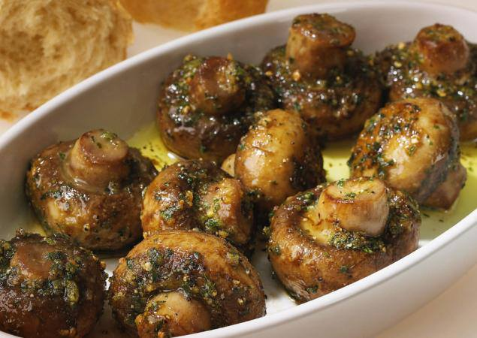
Roasted Garlic Mushrooms
Ingredients:
16 even-sized open cup mushrooms, stalks cut level
3 tbsp corn or vegetable oil
75g unsalted butter, softened
3 cloves garlic, chopped very finely
2 tbsp fresh thyme, chopped
1 1/2 tbsp lemon juice
salt and freshly ground black pepper to taste
50g fresh breadcrumbs
Directions:
Preheat the oven to 200C/400F/gas mark 6. Lightly fry the mushrooms, cap-side down, in hot oil for 20 seconds.
Arrange the mushrooms in a shallow roasting tin with the stalks facing upwards.
Mix together the butter, garlic, thyme, lemon juice and seasoning. Spoon a little garlic butter on to each mushroom, then lightly press the breadcrumbs on top. Either refrigerate for later use, or cook immediately in the oven for 10 minutes.

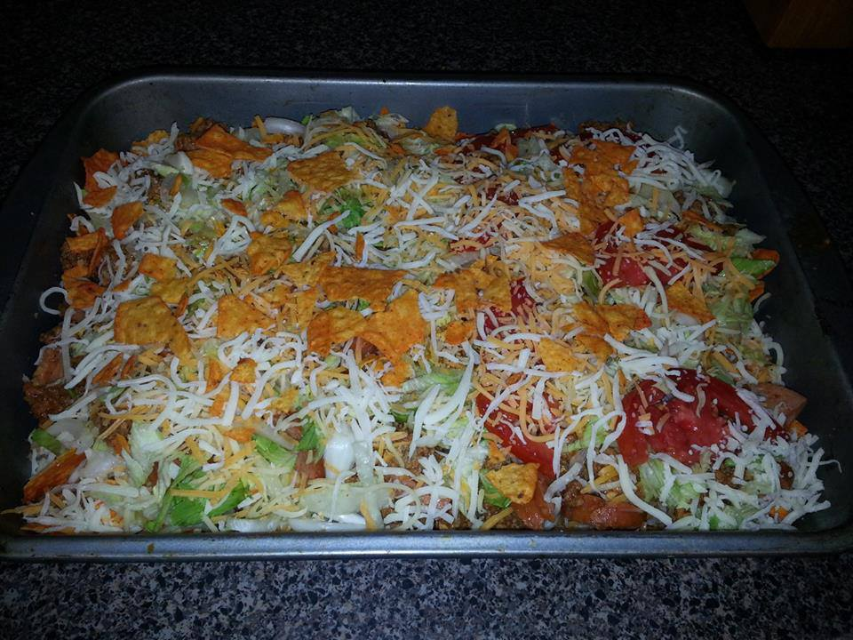
Taco Casserole – Salad – or Dip
My husband and 2 girls LOVE this Taco Casserole!
1 7oz. bag Nacho Cheese Doritos, crushed
1 lb. hamburger, browned
1 large can Refried Beans.. Heated
2 Cans Black Beans.. Mixed with Refried Beans and Heated
1 pkg. taco seasoning, mixed according to directions
1 (8 oz.) pkg. shredded Cheddar cheese
1 (8 oz.) pkg. shredded Mozzarella cheese
Chopped Onions..
Chopped Green Peppers
Shredded Lettuce
Sliced tomato
Sour Cream to dollup on the top
Guacamole to put on top too
Salsa.. Catalina.. Ranch.. You choose your favorite Dressing

Directions:
Brown the Hamburger with the Taco Seasoning according to directions on package.. ( I like to add to packages of taco seasoning to really make it spicy… That would be 2 packages per lb of Burger. )
Heat the Refried beans and black beans together…

Now put it all together.. Taco Meat, Then Refried beans on top.. Sprinkle some cheese.. Then add everything else.. You can layer it if you want.. Looks Nice in a Big Glass Bowl.. or you can spread it all out onto a big Turkey Platter.. and serve with Chips.. And call it a Taco Salad Dip.. It will be gone in Minutes !! Add any Taco Ingredient that you prefer.. Make it so flavorful by adding Lots of Everything !!!

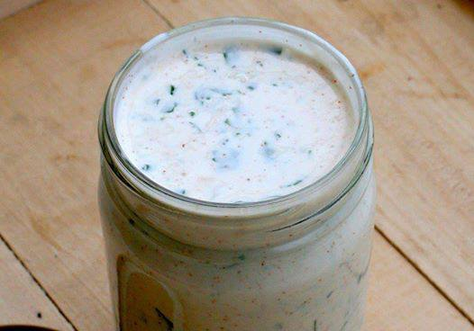
Ranch Dressing – Low Fat and Calories !
This whole jar of ranch is only 1.75 grams of fat and 255 calories!
1 cup plain Greek yogurt
1 packet hidden valley ranch mix
1/2 cup 1% milk.
Whisk together, chill 1 hour before use.
Perfect consistency and tastes better than bottled!

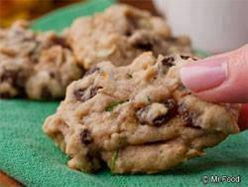
Fresh Zucchini Cookies
1/2 cup (1 stick) butter, softened
1 cup sugar
1 egg, beaten
2 cups flour
1 tsp baking soda
1 tsp ground cinnamon
1/2 tsp salt
1 cup grated zucchini
1 cup chocolate chips or raisins
1 cup nuts (optional)
Preheat oven to 350 degrees F. Coat baking sheets with cooking spray.
In a large bowl, cream together butter & sugar until light and fluffy. Gradually add eggs, floor and other dry ingredients.
Bake 15-17 minutes or until golden

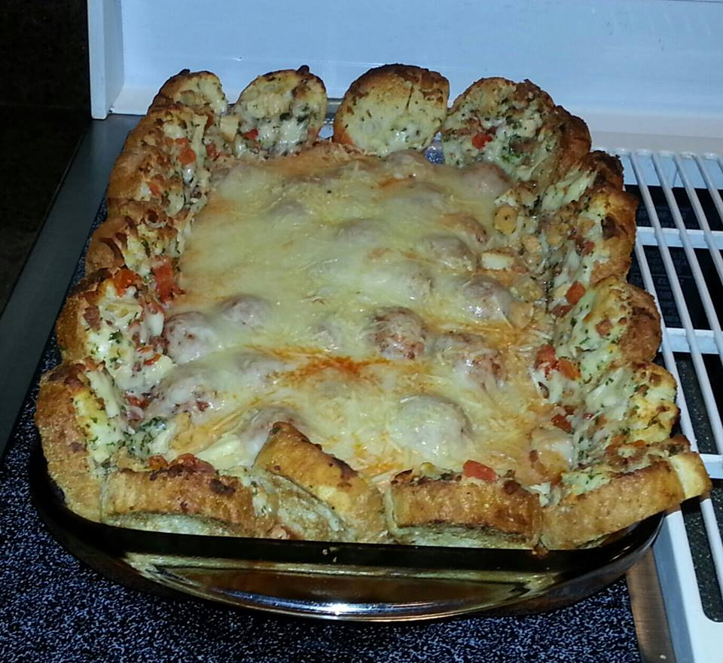
Meatball Sandwich Casserole
You will need:
! bag of frozen meatballs (I use Mama Lucia Brand, personal preference)
1 jar of marinara sauce or spaghetti sauce if there isn't any marinara on hand
1 cup mozzarella cheese, shredded
1 cup Italian blend cheese, shredded
1/2 cup Parmesan cheese, shredded
1 loaf of fresh Italian bread, sliced
To prepare:
Preheat oven to 400. Place entire bag of meatballs in pot with sauce (I also add garlic, onion powder, salt and pepper to taste) and cook over medium heat until warmed completely through, about 10 minutes. Stir as needed to keep meatballs from sticking to pot. Once heated through remove from heat. Place meatballs in the center of a 9x13 baking dish, layer mozzarella and Italian blend cheeses over meatballs topping off with the Parmesan. Take the slices of Italian bread and line the pan all the way around with them so that they are kind of keeping the meatballs toward the center of the pan. The bread slices will be standing up in the pan as shown in the picture. You have creative freedom here with the bread...you can lightly butter and garlic the bread prior to placing it in the pan if you prefer or even brush lightly with olive oil and garlic. The choice is yours. I have made it plain and as noted above and all are delicious!
Place in oven and bake for approximately 25 minutes or until cheese is melted and bubbly. Remove from oven, serve and enjoy!
A side salad goes nicely with this quick meal!

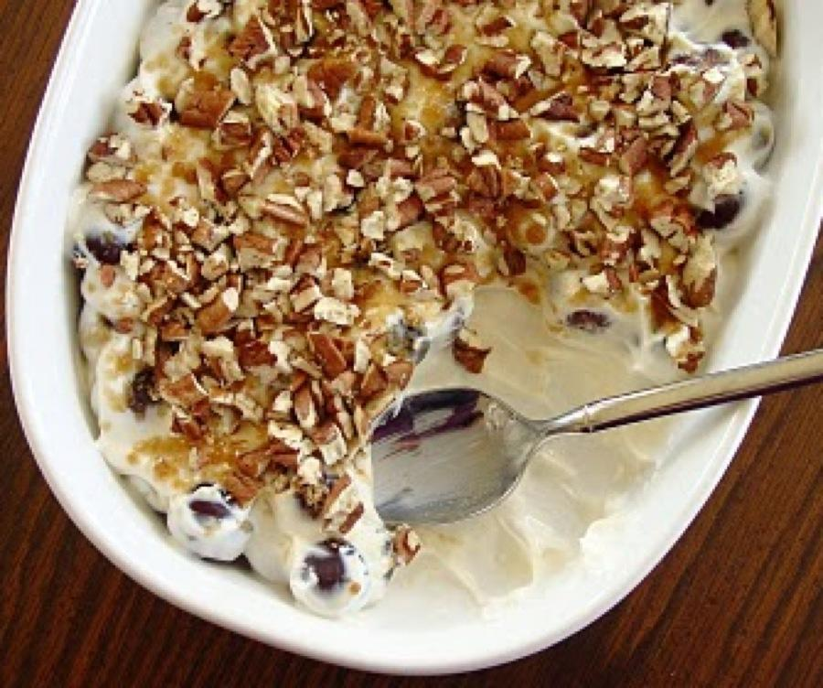
Sweet Grape Salad
Ingredients:
2 lbs. red seedless grapes
1 8-ounce package cream cheese, softened
1 8-ounce carton sour cream
1/2 cup white sugar
1 teaspoon vanilla
2 tablespoons brown sugar
2 tablespoons pecans
Preparation:
Combine cream cheese, sour cream, white sugar and vanilla in a large bowl. Gently fold in grapes.
Sprinkle with brown sugar, then pecan pieces.
Cover and refrigerate overnight or until well chilled.
Serve very cold.

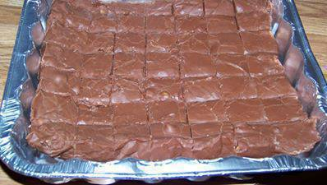
Easiest Fudge Ever

1 can Eagle brand condensed milk ( 14 oz )
1 1/2 bags of chocolate chips ( 11.5 oz bags is what I use) any flavor you wish
1 cup chopped walnuts ( optional )
Toss all ingredients in to a microwave bowl, melt till creamy pour into a 8x8 baking dish, cool for 2 hours cut and serve.

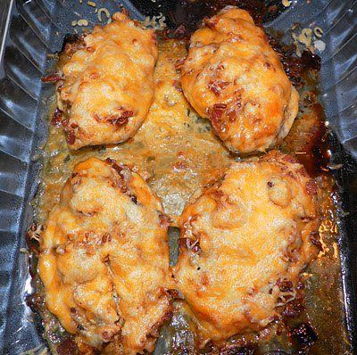
Outback Steakhouse Alice Springs Chicken

4 boneless skinless chicken breasts, pounded to 1/2 inch thickness
Lowry's Seasoning Salt
6 bacon slices
1/4 cup regular mustard
1/3 cup honey
2 Tbsp. Mayonnaise
2 teaspoons dried onion flakes
1 cup sliced fresh mushroom (I omitted because my family does not like mushrooms)
2 cup shredded Colby/Jack cheese
First, Sprinkle and rub the chicken breasts with seasoning salt. Cover and refrigerate for 30 minutes.
While the chicken is in the refrigerator, cook bacon in a large skillet until crisp. Remove bacon and set aside. ***Do not discard grease.***
Saute chicken in the bacon grease for 3 to 5 minutes per side, or until browned. Place chicken in a 9" × 13" casserole dish or pan.
To make the Honey Mustard: In a small bowl, mix the mustard, honey, mayonnaise and dried onion flakes.
Spread some of the Honey Mustard over each piece of chicken, then layer with mushrooms, crumbled bacon, and shredded cheese.
Bake in a 350° oven for 30 minutes, or until cheese is melted and chicken is done.
Serve with the left over Honey Mustard Sauce that you made

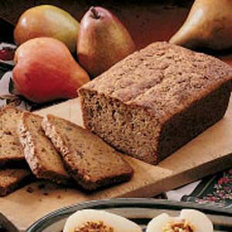
Pear Zucchini Bread

Ingredients

2 cups chopped peeled pears
1 cup shredded zucchini
1 cup sugar
1 cup packed brown sugar
3 eggs, beaten
1 cup vegetable oil
1 tablespoon vanilla extract
2 cups all-purpose flour
1 cup rye or whole wheat flour
2 teaspoons pumpkin pie spice
1 teaspoon baking soda
1/2 teaspoon baking powder
1/2 teaspoon salt
1/2 cup chopped pecans

Directions
In a large bowl, combine the first seven ingredients. Combine flours, pie spice, baking soda, baking powder and salt; stir into pear mixture until blended. Fold in nuts. Pour into two greased 8-in. x 4-in. loaf pans. Bake at 350° for 55-65 minutes or until a toothpick inserted near the center comes out clean. Cool in pans for 10 minutes; remove to a wire rack to cool completely. Yield: 2 loaves.

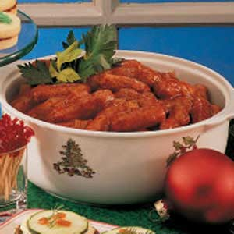
Party Style Smokies

3/4 cup chopped onion
2 tablespoons vegetable oil
1 cup ketchup
1/2 cup water
1/2 cup cider vinegar
2 tablespoons sugar
2 tablespoons Worcestershire sauce
2 tablespoons honey
2 teaspoons ground mustard
2 teaspoons paprika
3/4 teaspoon salt
1/4 teaspoon pepper
1/8 teaspoon hot pepper sauce
1 large lemon, sliced
2-1/2 to 3 pounds Little Smokies

Directions
In a saucepan, saute onion in oil until tender. Stir in the next 11 ingredients. Add lemon. Bring to a boil. Reduce heat; simmer, uncovered, for 20-25 minutes or until slightly thickened, stirring occasionally. Discard lemon slices. Place hot dogs in a 13-in. x 9-in. baking dish. Top with sauce. Bake, uncovered, at 350° for 18-20 minutes or until heated through. Keep warm; serve with toothpicks. Yield: 25-30 servings.

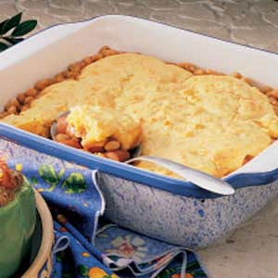
Franks and Corn Bread Recipe
Ingredients
2 cans (16 ounces each) pork and beans
1 package (12 ounces) hot dogs, halved lengthwise and sliced
2 tablespoons brown sugar
2 tablespoons Worcestershire sauce
2 tablespoons prepared mustard
1 package (8-1/2 ounces) corn bread/muffin mix
1 cup (4 ounces) shredded cheddar cheese

Directions
In a large bowl, combine the pork and beans, hot dogs, brown sugar, Worcestershire and mustard. Transfer to a greased 9-in. square baking dish.
Prepare corn bread batter according to package directions; stir in cheese. Drop by spoonfuls onto bean mixture. bake, uncovered, at 350° for 40-45 minutes or until heated through. Yield: 6 servings.

